Eids

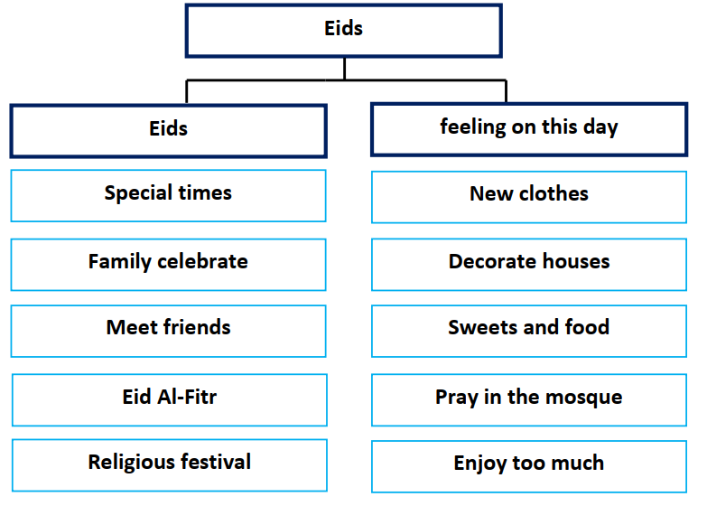

Eids are special times for family and friends. Family and friends
celebrate Eids together. I always meet my friends in Eids. Eid Al-Fitr is a
religious festival. It comes with happiness and joy.
In Eids, we decorate the house with beautiful things. We wear new
clothes. In the morning, we go to prayers in the mosque. Young people
receive gifts and money. We enjoy eating sweets and delicious food. I’m
very happy and I enjoy too much.

