The places of interest in Kuwait

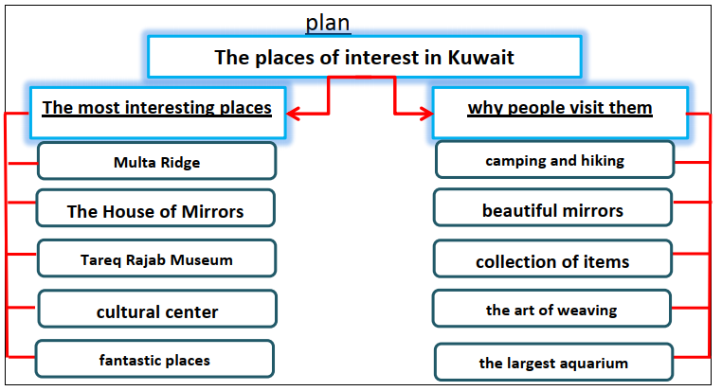

Kuwait has many places of interest. They attract tourists from all over the world. Multa Ridge is the highest point in Kuwait with hard-packed ground. Also, there is The House of Mirrors in AlQadsiya. Tourists can visit Tareq Rajab Museum. Bait Al Sadu is next to The National Museum of Kuwait. It became a cultural center. Kuwait has other fantastic places as Kuwait Towers, Red Fort and the Scientific center.
People visit these places for many reasons. They can enjoy camping and hiking in Multa Ridge. They enjoy the beautiful mirrors mosaic murals at The House of Mirrors. There is a great collection of items from different countries at Tareq Rajab Museum. Visitors can discover the art of weaving in different styles at Bait Al Sadu. They can see the largest
aquarium in the scientific center. Kuwait is a wonderful country with its fantastic places.

