My school day

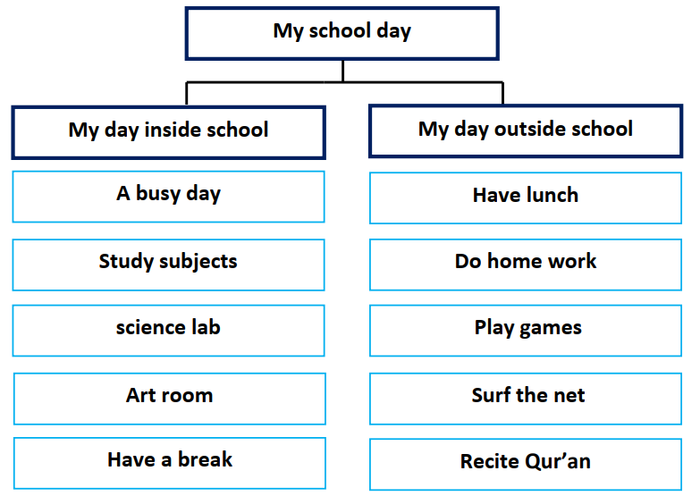

My school day inside school is a busy day. First, I meet my friends
in the morning and we enter the classroom. Next, we study different
subjects. Then, I enjoy working in the science lab and doing experiments.
After that, we have an interesting period in the art room. Finally, the
best time when we have the break in the school canteen.
After school it is another day. I come back home and have my
lunch. I do my homework and revise what I have studied. I have fun time
playing games with my brother. I enjoy surfing the net and chatting with
my friends. Finally, I recite some Qur’an and go to bed.

