2017

-

2018

Ministry of Education
Grade 1
0

Ahmadi Educational Area

Abdullah Al-Ahmad Al-Sabah Secondary School

Mr. Niazi Abdelaziz TRIKI
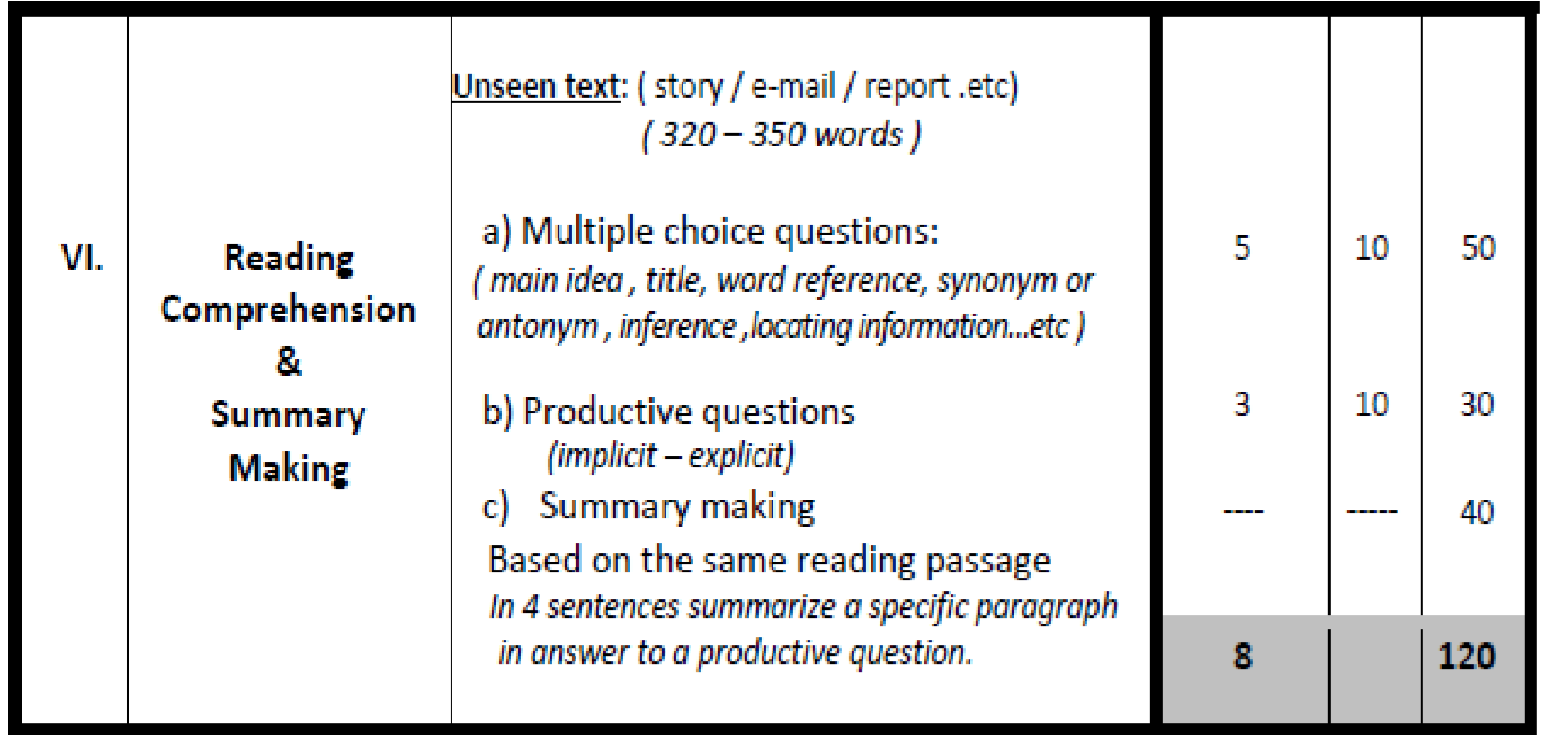

Grade 10
Reading Comprehension (120 Marks)
Carole Vincent, 46, describes what her life is like with a terrible eating disorder.
- Two o'clock in the morning and I'm wide awake. There's only one thing on my mind: food. My urge to eat is irrepressible. I try to push myself back to sleep, but I know I can't fight it. I walk down stairs to kitchen. Unconsciously, I search the cupboard for something that will stop my craving - bread, cereal, cheese, or biscuits.
- I return to bed and fall into fitful sleep, only to wake again in an hour or two - desperate to eat once again. When I get up for work and go into the kitchen, I find all the evidence of my late-night party. In a guilty rush, I recall what I did last night. While everyone else was fast asleep, I was consuming thousands of calories. I have Night Eating Syndrome for the whole of my adult life since my early 20s. I have never admitted it to anyone before - it was my shameful secret - and until a few weeks ago, I had no idea that what I had was an actual illness, with a proper name.
- While I was googling, I came across a story about a new eating disorder. The words 'night eating' caught my eyes. As I read on, I felt more and more excited. The article described obese people who ate little during the day and consumed carbohydrates at night. 'That's me!' I thought. I'm not the only person in the world with this problem. The relief was indescribable.
- Today, I weigh about 60 kgs, but just six months ago I was 110 kgs. My selfesteem and self-confidence are back again. My weight decreases hugely, depending on how much I'm able to control the quantity of food I eat at night. But however much I try; I can't totally get rid of the night eating pattern.

Daily Mail - By Richard H. Adamson -December 19, 2012

I- Choose the correct answer from a, b, c and d: (5 x 10 = 50 M)

1- The text is mainly about ………………………………………………………………….…...
- a gourmand lady who is addicted to social network websites
- a brave lady who went on a healthy diet for many years to keep fit.
- a fat young lady who vainly tried to lose weight despite her tough diet.
- a strongly-willing woman who managed to drop almost half her weight.

2- When Carole says: “The relief was indescribable,” she means that ……………………………………. a. she was totally confused about her situation.
- she was extremely reassured by the good news.
- she was unable to describe her own health problem.
- she was surprised that no one knew about her secret

3- The underlined word "it" in paragraph 1 refers to ……………………………… a. the fact of being awake
- the irresistible urge to eat
- staying up till early morning
- pushing oneself back to sleep

4- All the sentences below are true except: Before losing weight, ……………………………….. a. at the physical level, Carole suffered from obesity.
- at the psychological level, Carole felt self-confident.
- at the social level, Carole feels ashamed of food addiction. d. at the nutritional level, Carole used to eat too much at night.

5- We can infer from the reading passage that ……………………………………………………………. a. Carole is single and lives alone.
- Carole consumes food in spite of her.
- Carole has never eaten at night since she lost weight.
- Clarence was sure that the article was talking about her.
II- Answer the following questions: (3 x 10 = 30 M)
- How did Carole find out about her eating health problem?
……………………………………………………………………………………………………………..…….

- What makes Carole feel guilty when she gets up in the morning?
……………………………………………………………………………………………………………..……..

- How much weight has Carole lost after changing her eating habits?
……………………………………………………………………………………………………………..……..

III- In four sentences of your own, summarize paragraphs 1 and 2 showing the symptoms of Night Eating Syndrome: (4 x 10 = 40 M)

…………………………………………………………………………………………………………………..
…………………………………………………………………………………………………………………..
…………………………………………………………………………………………………………………..
…………………………………………………………………………………………………………………..

