2017

-

2018

Ministry of Education
Grade 12

Ahmadi Educational Area

Abdullah Al-Ahmad Al-Sabah Secondary School

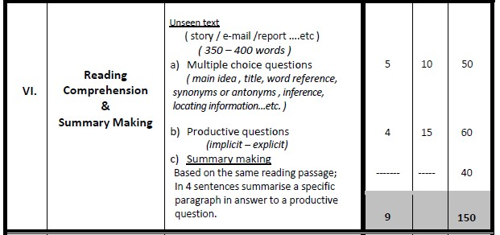
Mr. Niazi Abdelaziz TRIKI

Grade 12
Reading Comprehension (150 Marks)
- Wanjiru Mauine, the three-year-old girl, sits patiently on her bed, gazing at the unfamiliar medical equipment surrounding her. She has a surprised look on her face. Born with a cleft lip, she is among the fortunate few to be treated at the Kenyatta University Hospital in Nairobi, thanks to the kindness of medical volunteers sent by charity Operation Smile.

- Her treatment is free of charge. The charity advertised its visit last January and word spread fast. Charles says: “I’ve been fixing bicycles and doing whatever jobs I can find to come here. My daughter is my Achilles' heel. I want my daughter to wear a self-confident smile. I also like her to be able to speak correctly so she does well at school. I’m proud and more than happy to have earned the money to do this for her.”

- Operation Smile was created in 1982 to correct facial deformities in children. Since then, the charity has become a global organisation and now has 5,000 registered medical and non-medical professional volunteers, deployed in many countries. It has treated more than 100,000 children in 25 countries. Each volunteer commits two weeks of his time and pays £300 to join a project. Cleft lip and palate affects around one in 500 babies. In Britain, infants are treated soon after birth; however, just one in four receive medical assistance in the developing world.

- Wanjiru’s surgeon , Ankur Pandya, undertook his first Operation Smile mission a year ago and has completed three more since. His own successful battle with cancer prompted him to help others unable to obtain medical assistance as easily as he had. “I received a lot of medical care and support from friends and colleagues in the medical community. Ever since, I’ve been committed to giving something back,” he says. "The next time I see Wanjiru and her father, after the operation, tears of joy well up in his eyes. ” “My daughter will now have a good future,” he smiles. “She looks completely different. I’m looking forward to showing my wife her new smile. She won’t recognise her.”
Despite her pain, Wanjiru manages a cheery smile, her first of many.

I- Choose the correct answer from a, b, c and d: (5 x 10 = 50 M)

1- The title that best fits the text is ………………………………………………………………..
- The Gift of a Smile
- How to Join a Charity
- A Friend in Need Is a Friend Indeed d. A Surgeon Challenging a Deadly Disease 2- The underlined word "his" in paragraph 4 refers to ………………………………………….. a. Charles
- Wanjiru
- Kenyatta
- Ankur Pandya

3- The antonym of the underlined word "proud" in paragraph 2 is ……………………………… a. furious
- ashamed
- impressive
- disgruntled

4- All the sentences below are true except: a. Wanjiru's family paid for her treatment
- Charles did his best for the sake of Wanjiru
- Dr. Ankur Pandya used to suffer from a fatal disease
- Dr. Ankur owes his recovery to friends and colleagues

5- All the sentences below are not true except: a. Volunteering within this organization is free
- Wanjiru's mother became so glad after seeing her daughter's smile
- Dr. Ankur Pandya has undertaken four Operation Smile missions so far
- All Kenyan deformed babies receive the necessary medical assistance early

II- Answer the following questions: (4 x 15 = 60 M)

- What encouraged the Surgeon to help people?
……………………………………………………………………………………………………………..…….

- Complete the sentence with evidence from the passage.
Cleft lip is a rare facial deformation because ……………………………………………………………...

- What is Dr. Ankur Pandya's lifelong commitment?
……………………………………………………………………………………………………………..……..

- What benefits will Wanjiru gain after being operated?
……………………………………………………………………………………………………………..……..

III- In four sentences of your own, summarize the third paragraph showing how and why Operation Smile has become a famous charitable organization: (4 x 10 = 40 M)

…………………………………………………………………………………………………………………..
…………………………………………………………………………………………………………………..
…………………………………………………………………………………………………………………..
…………………………………………………………………………………………………………………..

