Renewable energy
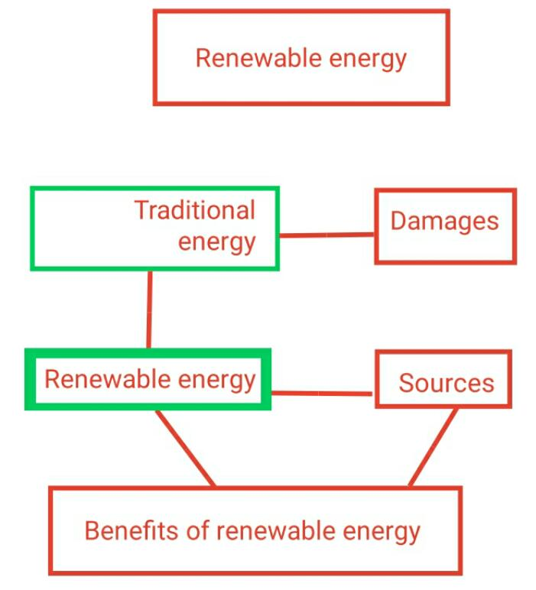

The dependence on traditional energy that depends on petroleum and its derivatives, coal and natural gas has caused great harm to humans and other living organisms, as it caused environmental pollution, global warming and other damages. This made all countries of the world seek to rely on clean renewable energy.
Renewable energy is energy derived from natural resources that is replenished or cannot be depleted. Renewable energy is produced from wind, sun and water. It can also be produced from the movement of waves and tides, as well as from some agricultural crops and trees that produce oils. This energy is also produced from underground energy. So it is clean energy, as it has a low production cost, and it contributes to improving human livelihood. As it secures new job opportunities for him.
And since it is a clean energy, it will lead to a reduction of harmful gaseous and heat emissions and their results. In addition, it will contribute to reduce the number of natural disasters resulting from global warming.
Renewable energy preserves the natural environment, protects all living things , and protects fish wealth , also agricultural yields will increase due to the elimination of pollutants .

