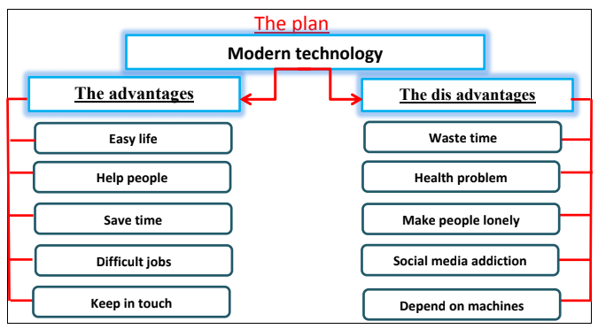

Modern technology

In fact, modern technology plays a vital role in our life. It has changed the way we live completely. It has many advantages. It makes our life easier and more comfortable. Also, it saves time and effort. In addition, it helps people in difficult and dangerous jobs. Depending on modern technology enables us to keep in touch with the latest progress in all fields of life.

However, modern technology has some disadvantages. These disadvantages are results of the bad use of technology. It may waste time. Some people are addicted to social media. It may lead to some health problems. Depending on machines completely makes people lazy and lonely.

