Technology
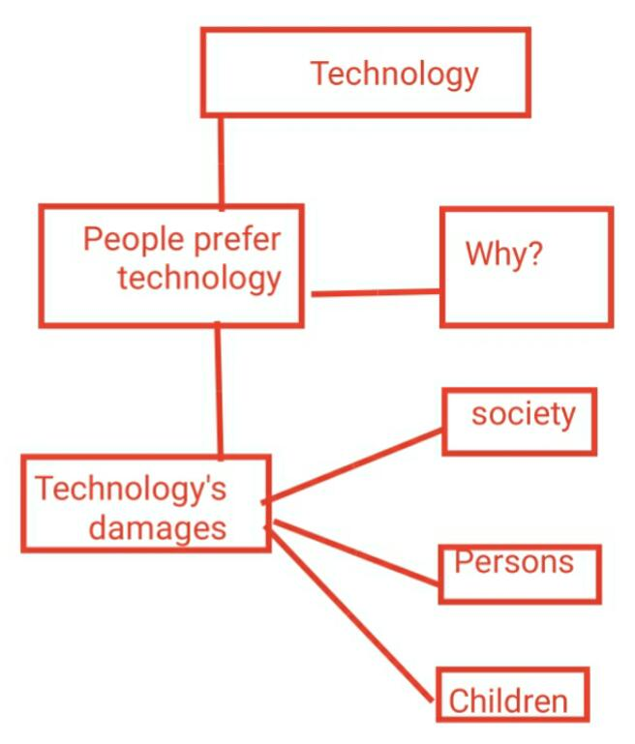

Technology is accepted and preferred by the vast majority of people , as it is the best way to solve society's problems . However, there are those who have great doubts about the impact of technology on society .
The problem is that technology is not limited to specialists and experts , but has become a tool that is used by all people . As it is rare to see a person without a mobile phone or a personal computer .
Technology is a double-edged sword , and despite its benefits in transforming our lives from routine and imitation to speed and ideas , it is not without its drawbacks , as some specialists believe that technology has marginalized the role of the individual in performing tasks , especially after the emergence of machines that play the role of the individual.
In addition to the fact that technology has contributed to create some problems , such as the emergence of economic and social differences between people , in addition to the impact of technology on children , as it contributes to change their way of thinking , for example video games that make children tend to isolate , which distracts them , and weakens their ability to remember, especially those children who use Internet search engines . Human dependence on technology such as cars , computers , remote control devices and other means has led to an increase in human laziness , which has led to an increase in obesity rates.

