New media
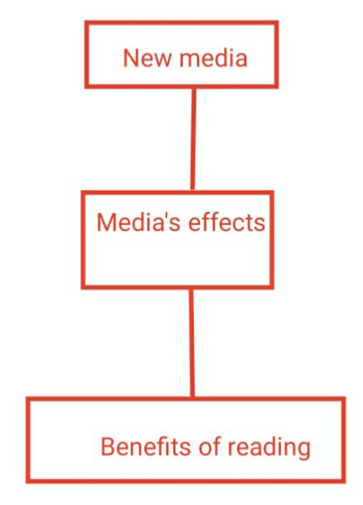

The media is one of the most important achievements that the world has reached in the modern era . It has become a necessity , as it is useful in reporting direct events .
Although the media has saved effort and time in several areas , it has many drawbacks , including spreading charlatanry and promoting violence and crime , depicting nudity as personal freedoms , as well as fatigue and laziness .
New media causes lethargy for children , and has a great effect on their growth and behavior.
Reading is , as we know , the best friend and friend of the reader , and the benefits of written and read media have greater benefits such as raising awareness , raising the level of social , cultural and political awareness for the reader , as well as increasing the reader's linguistic balance , and strengthening his language .

