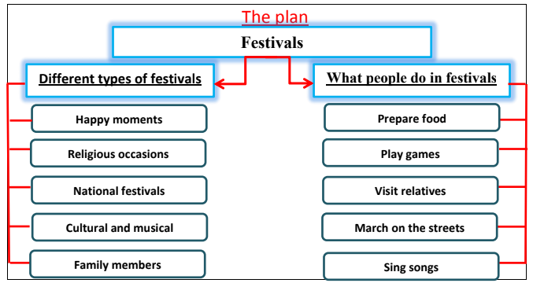

Festivals

Festivals are happy moments and you cannot really enjoy them on your own. There are different types of festivals. There are religious festivals which Commemorate religious occasions. Also, there are national festivals which are related to the country. There are cultural and musical festivals. Family members have the chance to meet together during family celebrations.

People can do many things during festivals. They perform prayers. They meet up with friends and visit their relatives. Delicious food and sweets are prepared. Others march on the streets, sing songs and play games. Some people prefer travelling abroad and sharing others with their celebrations.

