Money
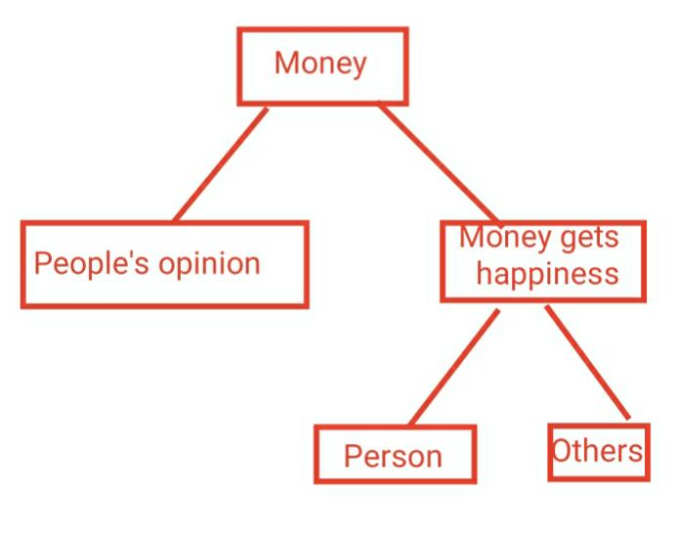

Money has a big role in people's lives, as they need it to run all aspects of life. And about the relationship of money with happiness, there are those who believe that there is no connection between the two, and that their happiness comes from matters such as health and children's success.
Others think that money is a safety, as having enough money means not feeling anxious about life matters , just as money provides its owner the opportunity to live certain experiences , such as travel , and thus gets pleasure , just as money helps in learning new things, such as learning music , or spending on sports centers to reach a healthier and leaner body .
Also the presence of money helps its owner to donate to charitable organizations to help the needy , and this makes others happy.
With money it is possible to spend to gain time , so when you have money you can pay others to do the work for you instead of you , which will save your time . In addition to those , the ability of buying goods , these are what the money saves .

