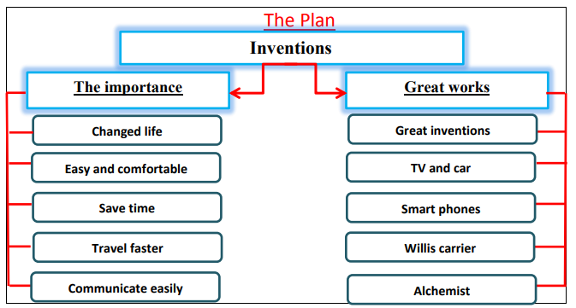

Inventions
Inventions have changed our life completely. It makes our life easier and more comfortable. It saves our time and effort. It enables us to travel around the world faster. Also, we can communicate with others easily.
There are some great inventions that changed our life. TV, cars, planes and other means of transport are very important. Smart phone and super computers changed the way we communicate. Willis carrier invented the first A.c. Sadeq Ahmed Qasem is an Arabian inventor. He invented Alchemist. Steve jobs the inventor of Apple. These inventions have wonderful contributions that changed the world and helped the humanity.

