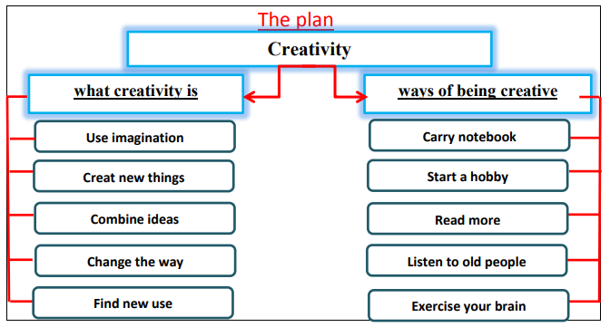

Creativity
Creativity is using your imagination to make something original. Everyone is creative in a way or another. You can create new things in many ways. Frist, you can combine two or more ideas to get a new one. Second, you should change the way you do things. Third, you can find new uses for things. Finally, you need evolution of ideas and act on your ideas.
To be creative, you should do some special activities. First, always carry a notebook and a pen. Second. You need to start a new hobby or sport. Third, you should read about things you are not interested in. Fourth, you need to listen to old people talking about life experience. Finally, you must exercise your brain, play chess or do puzzles. Having creative ideas is not enough; you need to act on them.

