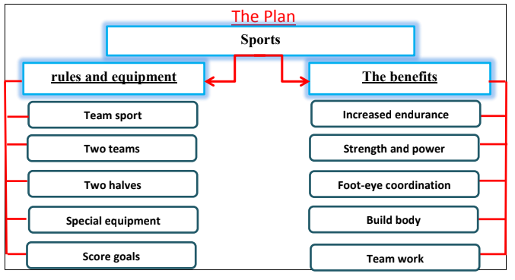
Sports

Football is one of the oldest sports in the world. It is the most famous of the team sports. There are some simple rules for the football game. There are two teams play a two-half game. They play on a pitch and use essential equipment. A referee controls the game. you have to kick a ball and score more goals to win the game.

Sport is very important. Football has many benefits. It increases the endurance. It builds up muscles and gives you a strong body. It increases the power in legs and foot-eye coordination. Taking part in a football game teaches you to co-operate and work as a team.

