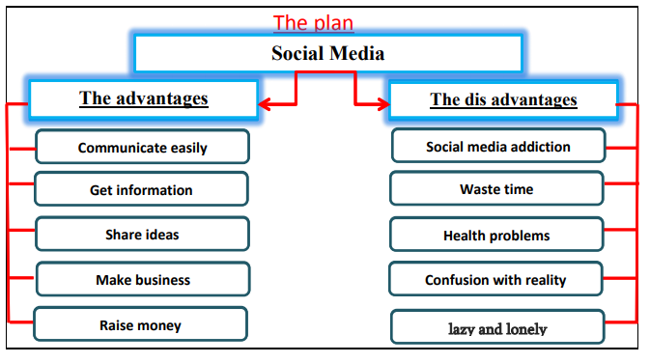
Social Media
Social Media Social media has become a huge part of everyday life. It has many advantages. It helps us to communicate with people easily. Also, people can get the latest news and information. In addition, they can share ideas and opinions on social media. People can raise money for charity and make business through social media.

However, social media has some disadvantages. These disadvantages are results of the bad use of social media. Some people are addicted to social media. It may waste time. It may lead to some health problems. Spending too much time on social media makes people lazy and lonely. Also, some people confuse social media with reality. Social media can spread false information. Finally, people should use social media wisely.

