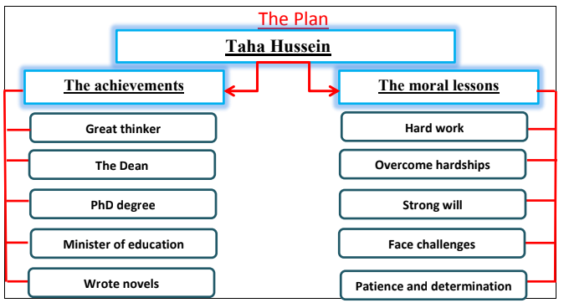

Taha Hussein

Taha Hussein is a famous writer. He was a great thinker and writer. Although he was blind, he wrote a lot of novels and short stories. He was called The Dean of the Arabic literature. He was the first to hold a PhD from Cairo university. He was appointed a minister of education. He got the national Honors prize in literature.

Taha Hussein’s life was full of lessons and morals. We can learn patience and determination. Hard work is the key for success. Don’t give up and face the challenges. You can overcome hardships by strong will. Finally, being disabled shouldn’t mean being unsuccessful it may be the motivation for doing miracles.

