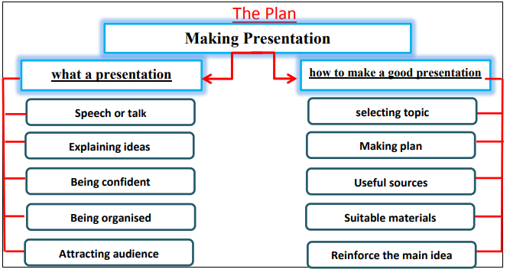

Making Presentation
Presentation is the process of presenting anew topic. It is a speech or a talk to explain a new idea. Preparation is the most important part of the good presentation. Being organized enables successful presentation. Also, you should have self-confidence to attract the audience attention.
There are many steps to make a good presentation. First, you need to select the topic. Second, decide how much information you can present. Third, set a time limit to focus on the content. Forth, choose the suitable materials and the useful sources that illustrate your idea. Finally, conclude your presentation with reinforcing the main idea of your presentation.

