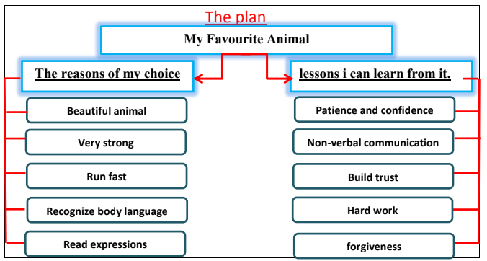

Dear ………. ,
How are you? I’m writing to tell you about horses. My favorite animal is the horse. It is a beautiful animal. It is very strong. It can run so fast. Horses are able to recognize body language. They can read human facial expressions.
When you deal with horses, you will learn many things. You will learn patience and confidence. You should have non- verbal communication to work with them. The longer you work with a horse, the more trust can be built. Horses are masters of forgiveness and hard work. Write soon and tell me about your favourite animal and what you learn from it.
Best wishes
Yours,
………..

