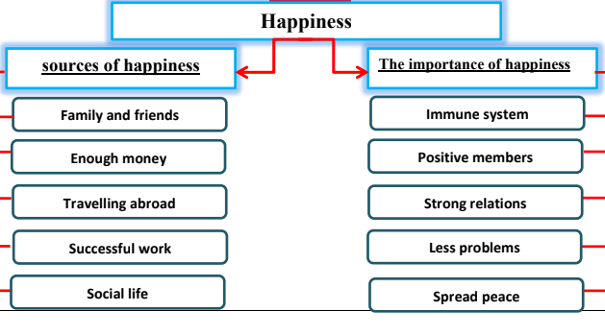

Happiness

Happiness is a state of mind. It is the feeling of being happy. There are many sources of happiness. Family, friends and enough money are the main sources of happiness. Also, successful social life and work ensure happiness. Some people find happiness in travelling abroad and breaking the daily routine. Positive thinking leads to moments of happiness.
Happiness is very important for individuals and societies. It is good for health. It gives you a strong immune system. Happy people enjoy their life and they are positive members. Happiness builds strong relations among people. This means less problems and peace spreads in the society. When you have a harmony between what you think and what you do then you are happy.

