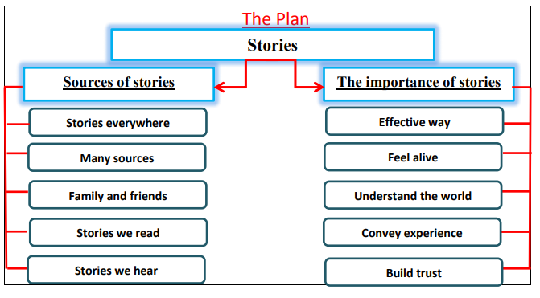

Stories
Stories are everywhere. There are many sources of stories. There are Stories from our family and friends. There are stories we read in books and magazines. We hear stories at school, at work on radio and TV.
Stories are the most effective way to communicate and deliver messages. Stories are very important. They inspire us and make us feel alive. Stories help us to understand the world. They convey emotional and personal experiences. They quickly build trust between the speaker and the listener. Behaviours can be changed through stories. Finally, stories are creative tools to teach and learn morals.

