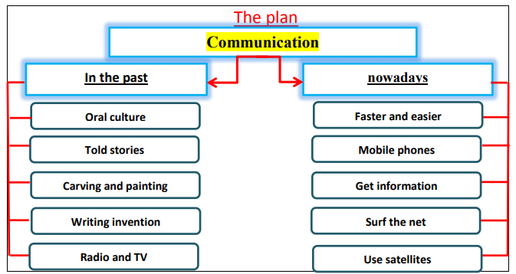
communications
Communication has improved over years. In the past, people depended on the oral culture. Older people told stories to the younger generations. Then, people learned carving and painting on stones. People were able to write down what they knew after writing was invented. The invention of TV, radio and computer changed the way of communication.
Nowadays, the way we communicate has changed completely. It becomes faster and easier. People can communicate in different ways. They use mobile phones to make calls, send and receive messages. People also use the radio, television and computers for communication. They get a lot of information when they surf the internet. People use satellites to communicate across the globe. Communication is improving all the time.

