TV

Introduction:
TV has become increasingly important in our lives. Some people find it essential and others however think we can do without it.

Body:

Paragraph 1 :
arguments for TV.
- main source of information.
- stay current
- available everywhere
- educational benefits

Paragraph 2 :
arguments against TV.
- other sources of information.
- Net is more beneficial.
- waste of time.
- silly programmes

Conclusion:
I personally like to watch TV from time to time. I think we should not ignore the role and benefits TV has

TV has become increasingly important in our lives. Some people find it essential and others however think we can do without it.
There are many reasons that make some people depend on TV. TV has been and is still a main source of information for people. It helps them stay current and know what is going on in the world. TV is almost available everywhere and for everyone. Most people tend to turn TV on once they are informed there is breaking news. Moreover, TV is essential as it has educational benefits for children and adults. It can help you learn new languages thanks to the educational channels. It helps you be connected to the world and learn a lot.

Some people however think that TV is not that good. They argue that TV is not the main source of information. The Net helps you stay current and connected more than TV does. You can learn up to date information without depending on TV. Some people even say that TV is waste of time. It sometimes introduces silly programmes for viewers. Added to that, TV can affect one's behaviour and mainly kids who are still immature. It can as well give false view of the world.

I personally like to watch TV from time to time. I think we should not ignore the role and benefits TV has.

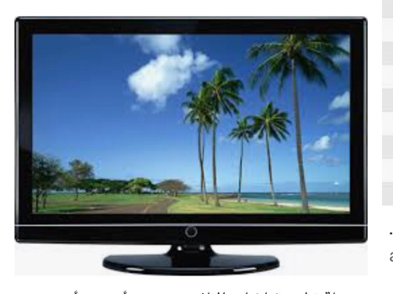
Hajar Alenzi
11-2

