Grade : 66666666

**Units: 1 , 2 , 3**

**Unit one - A famous artist**

**Vocabulary**

|  |  |  |  |  |  |  |
| --- | --- | --- | --- | --- | --- | --- |
| **Word** | **Part of speech** | **Meaning** |  | **Word** | **Part of speech** | **Meaning** |
| **model** | **(n)** | **نموذج** |  | **Background** | **(n)** | **خلفية** |
| **cot** | **(n)** | **سرير الطفل** |  | **foreground** | **(n)** | **أمام** |
| **palm leaves** | **(n)** | **سعف النخيل** |  | **middle** | **(n)** | **منتصف** |
| **own** | **(n)** | **يمتلك** |  | **furniture** | **(n)** | **أثاث** |
| **move to** | **(ph.v)** | **ينتقل إلى** |  | **made of** | **(ph.v)** | **مصنوع من** |
| **collect** | **(v)** | **يجمع** |  | **soundly** | **(adv)** | **بعمق-بهدوء** |
| **rough** | **(adj)** | **(البحر )هائج** |  | **show** | **(v)** | **يعرض** |
|  | **pass away** | **(ph.v)** | **يموت** |

**a. Choose the correct answer from a, b, c and d**

1- That baby is sleeping soundly in his--------------.

**a) cot b) palm leaves c) model d) furniture**

2- My grandfather…………….. ………………….. at the age of 92.

**a) collected b) showed c) passed away d) made**

3- My family bought new ……………………… for our new villa.

**a) cot b) middle c) palm leaves d) furniture**

4- My uncle …………………………. a big house. He is rich.

**a) passes away b) owns c) collects d) shows**

**b) Choose the correct answer from a, b, c and d**

**1-** The artist painted a …………………… of Kuwait Towers .

**a) cot b) middle c) palm leaves d) model**

**2-** The mother was sad because her son …………………… away.

**a) showed b) passed c) moved d) made**

**3-** He likes …………………… shells on the beach. It's his hobby.

**a) collecting b) moving c) owning d) showing**

**4-** I bought some new …………………… for my house.

**a) model b) furniture c) background d) middle**

**c) Fill in the spaces with the most suitable words from the list :**

**( palm leaves - moved - owns - middle - show )**

1- My brother ………………………. an expensive car.

2- Great artists ………………………their paintings in the museums.

3- A Manazz used to be made of ……………………….

4- My family ………………………. to a new house last week. 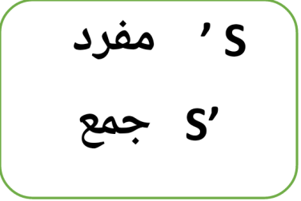

1. Grammar
2. **This is my sister’s car. She drives it carefully.**
3. **This is my uncle’s son. He is a doctor.**
4. **Miss Maha is the students’ teacher. They respect her.**

**Used to ////// didn't use to + infinitive( (مصدر**

**a. Choose the correct answer between brackets:**

I **(use to - used to – am used to )** drink milk when I was young, but I **(didn't – don't – doesn't )** use to drink coffee. All children at my age used

**( in – for – to )** have the same habit. I didn’t use to **( drinking – drink – drinks )** fizzy drinks.

**b. Choose the correct answer between brackets:**

I **( am – was – were )** born in 2012 in Kuwait. I **( used – uses – using )** to drink milk when I was five years old. I didn't **( used – use – using )** to drink tea. My friend used to **( lives – lived – live )** in a city.

**Do as shown between the brackets:**

**1- He used to come to school late. (Make negative)**

…………………………………………………………………………………………………………

**4- Hani used to play football in the park. ( Ask a question )** …………………………………………………………………………………………………………

**Writing**

**Everyone has his own hobby. " Plan and write a paragraph (not less than 8 sentences) about "Painting" These guide words may help you :**

**(hobby - need - colours -good at - free time - draw- teacher - artist)**

**Plan your topic here**





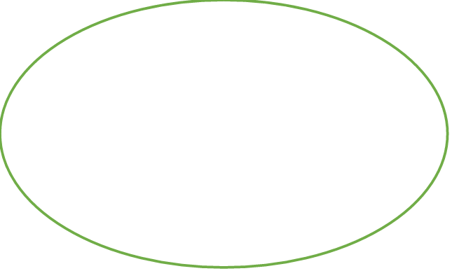





**Write your topic here**

………………………………………………………………………………………………………………………………………………………………

………………………………………………………………………………………………………………………………………………………………

…………………………………………………………………………………………………………………………………………………………….

…………………………………………………………………………………………………………………………………………………………..

…………………………………………………………………………………………………………………………………………………………..

**Spelling**

**Rewrite the underlined words correctly:**

1- There is a piece of **fruntirue** in the **ferorguond** of the picture.

………………………………………………………………………………………………………………………………………………………………

2- I **clolcet** shells because I want to **sohw** them in the museum.

………………………………………………………………………………………………………………………………………………………………

**Unit 2 - Vocabulary**

|  |  |  |  |  |  |  |
| --- | --- | --- | --- | --- | --- | --- |
| **Word** | **Part of speech** | **Meaning** |  | **Word** | **Part of speech** | **Meaning** |
| **advertisement** | **(n)** | **إعلان** |  | **miss** | **(v)** | **يفقد** |
| **sphere** | **(n)** | **مجسم كروي** |  | **edition** | **(n)** | **إصدار- نسخة** |
| **businessman** | **(n)** | **رجل أعمال** |  | **price** | **(n)** | **سعر- ثمن** |
| **feed** | **(v)** | **يطعم** |  | **browser** | **(n)** | **متصفح** |
| **Happily** | **(adv)** | **بسعادة** |  | **deal** | **(n)** | **صفقة** |
| **scuba diving** | **(n)** | **الغوص بالمعدات** |  | **exciting** | **(adv)** | **رائع- مثير** |
| **Tasty** | **(adj)** | **لذيذ** |  | **Shows** | **(n)** | **عروض** |
| **aquarium** | **(n)** | **حوض سمك** |  | **Old-fashioned** | **(adj)** | **قديم الطراز** |
|  |

**a. Choose the correct answer from a, b, c and d**

1- There are a lot of …………………………………….…in the newspaper.

**a) advertisements b) spheres c) editions d) deals**

2- My father is a ……………………………………………………………….… He is rich.

**a) price b) aquarium c) scuba diving businessman.**

3- My mother always cooks …………………………………….…food.

**a) exciting b) tasty c) broken d) old – fashioned**

4- I …………………………………….… the school bus so I came to school late.

**a) collected b) missed c) fed d) owned**

**b) Fill in the spaces with the most suitable words from the list :**

**1-** I watched an …………………… film in the cinema last week.

**2-** Don't ……………………………..the last edition of I phone .

3- We had a …………………… meal in the restaurant yesterday.

4- Don't ………………………………sharks in the aquarium.

**Grammar**

**First conditional**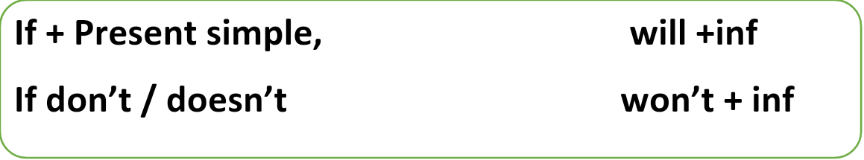



**Won’t**

**If + مضارع بسيط will + مصدر** 

**1- If I have money, I will buy a car.**

**2- If he sleeps early, he will get up early.**

**Choose the correct answer between brackets:**

If Sami doesn’t hurry up, he **( misses – will miss – missed)** the school bus. If he misses the school bus, he **( be – will be – would be )** late for school.

**Do as shown between the brackets:**

**1-If she does sports , she (be) healthy. (Correct)**

…………………………………………………………………………………………………..

**2- If I do sports**,…….................................................................................. **( Complete)**

…………………………………………………………………………………………………..

**5- If it ( be ) hot, I'll go swimming. ( correct )**

…………………………………………………………………………………………………..

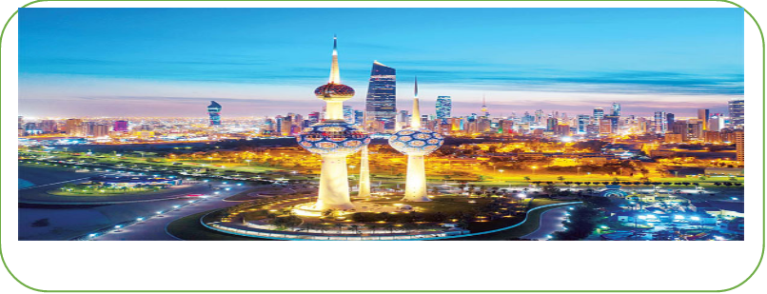

**(1)Composition "**

“Kuwait is a wonderful country with many places to visit" Plan and write a paragraph not less than [8 sentences] about “The most interesting places in Kuwait" The following guide words may help you.

**( interesting / old / The Red Palace / visit / modern / malls / go / Aquarium)** 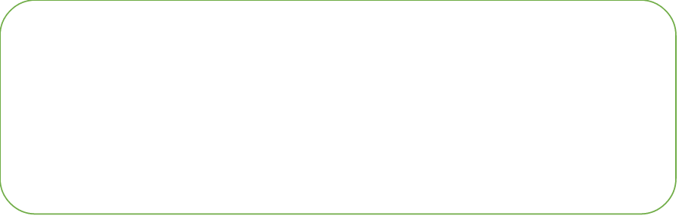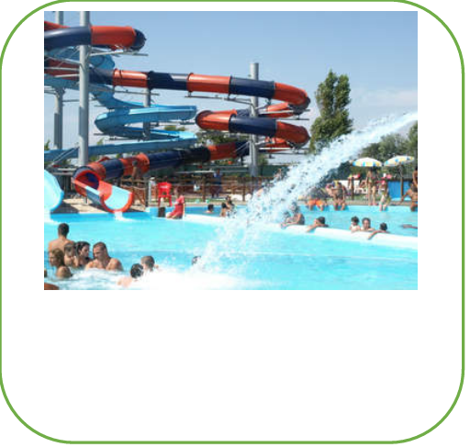

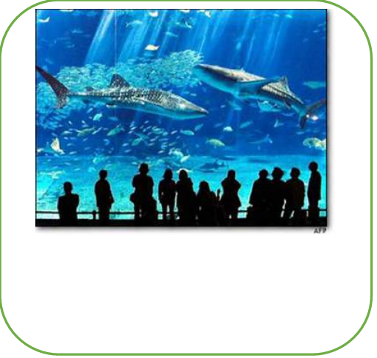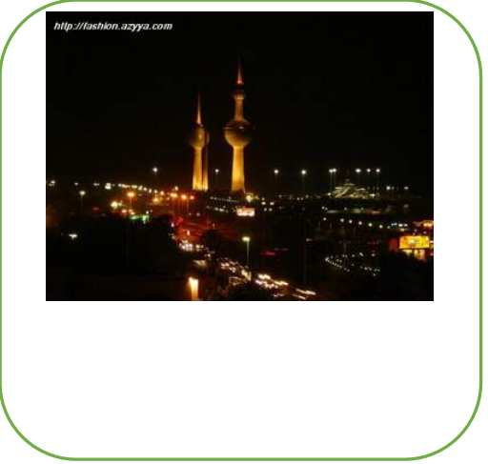

**Plan your topic here**











**Write your topic here**

**Spelling**

**Rewrite the underlined words correctly:**

1- **Sucab idinvg** is an **eicxting** sport.

………………………………………………………………………………………………………………………………………………………………

2- I bought the new **etidoin** of my favourite game.Its **pcrie** is high

………………………………………………………………………………………………………………………………………………………………

**Unit 3 ----Vocabulary**

|  |  |  |  |  |  |  |
| --- | --- | --- | --- | --- | --- | --- |
| **Word** | **Part of speech** | **Meaning** |  | **Word** | **Part of speech** | **Meaning** |
| **receptionist** | **(n)** | **موظف استقبال** |  | **Remember** | **(v)** | **يتذكر** |
| **worried** | **(adj)** | **قلق** |  | **x-ray** | **(v)** | **يصور صورة أشعة** |
| **programme** | **(n)** | **برنامج** |  | **Safety** | **(n)** | **أمان- سلامة** |
| **hastily** | **(adv)** | **بسرعة** |  | **Hit** | **(v)** | **يصطدم** |
| **cartoon** | **(n)** | **رسوم متحركة** |  | **Actor** | **(n)** | **ممثل** |
| **prefer** | **(v)** | **يفضل** |  | **Episode** | **(n)** | **حلقة** |
| **daughter** | **(n)** | **ابنة** |  | **Broken** | **(adj)** | **مكسور** |
| **leave** | **(v)** | **يترك / يغادر** |  | **Frightened** | **(adj)** | **مرعوب- خائف** |
|  |

**a. Choose the correct answer from a, b, c and d**

1- My favourite TV…………………..……is cartoon .

**a) programme b) sphere c) cot d) furniture.**

2- The fast driver ……………the young boy who was walking in the street.

**a) show b) hit c) feed d)collect**

3- I lost my keys. I couldn’t…………………….…where I put them.

**a) remember b)prefer c)collect d)hit**

4-I …………..watching documentary films. They are exciting.

**a)prefer b) hit c) x-ray d)collect**

5-My favourite ………………. is Tom & Jerry.

**a)daughter b) receptionist c) cartoon d) furniture**

**b) Fill in the spaces with the most suitable words from the list :**

**hit – frightened – leave –worried – remember**

**1-I couldn't …………………..where I put my keys.**

**2-The parents were …………………….about their sick daughter.**

**3-They will…………………their house and move to a new one.**

**4-Children sometimes feel ..................................of animals .**

**Grammar**

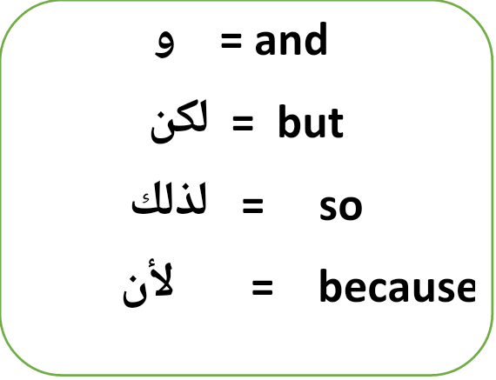**Conjunctions:**

**Choose the correct answer between brackets:**

Hani ( **or – and – so** ) I are close friends. He likes swimming

( **or – but – because** )I prefer watching cartoons. Hani was ill last week,

**( so – and – because )** he didn’t come to school .I'll visit him **( and – so – because )** he is my best friend .

**Do as shown between the brackets:**

1- Rami can't run fast. He is very fat. ( join: because) ……………………………………………………………………………………………………………………

2- Mona was very ill. She went to the hospital. ( join:…so )

……………………………………………………………………………………………………………………

**الزمن الماضي البسيط : The simple past tense ( 2nd form of the verb ):**

**Key words : yesterday , ago , last……., ago**

**Examples**

**bought , travelled , went , ran , played , was , were , visited, used**

**Examples :**

**Where did you go last week ?**

**I went to the club .**

**Yes / No questions :**

**A ) Did you enjoy your trip ?**

**B ) Yes , I did . No , I didn't .**

**Question words**

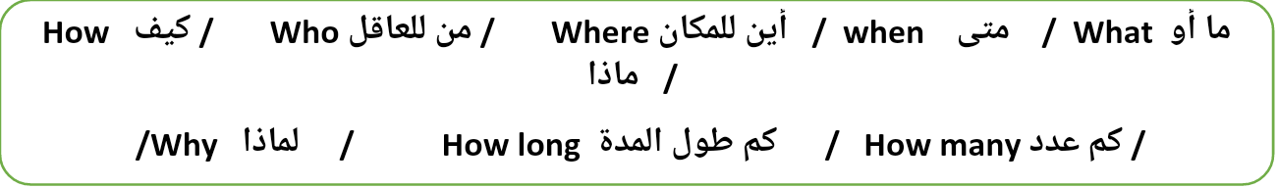

**Do as shown in brackets:**

**1. I ( visit ) my uncle yesterday. ( correct )**

…………………………………………………………………………………..………………………………..

**2.We ( buy ) our food from the market last Friday. ( correct )**

…………………………………………………………………………………..………………………………..

**3. I watched a film last week. ( Negative )**

…………………………………………………………………………………..………………………………..

**- The boy ate a delicious cake two hours ago. (Ask a question)**

…………………………………………………………………………………..………………………………..

**7- Rami went to school by bus. (Ask a question)**

…………………………………………………………………………………..………………………………..

**Choose the correct answer :**

Last holiday I ( travel – travelled – am travelling ) to Malaysia with my family. We

( go – went - goes ) there by plane. We ( stay – staying – stayed ) in a big hotel.

We ( visit – visits – visited ) wonderful places.

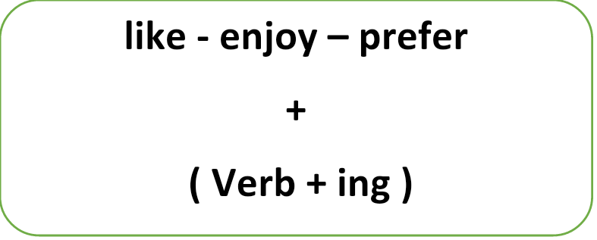

**1- I like ( listen) to music. ( Correct )**

……………………………………………………………………………………………………………

**2- She enjoys ( cook ) everyday. ( Correct )**

……………………………………………………………………………………………………………

**3- We prefer ( play ) tennis. ( Correct)**

……………………………………………………………………………………………………………

**4- They always go ( sail ) . ( correct )**

……………………………………………………………………………………………………………

"**Car accidents are very dangerous." Plan and write a paragraph (not less than 8 sentences) about "car accidents" These guide words may help you :**

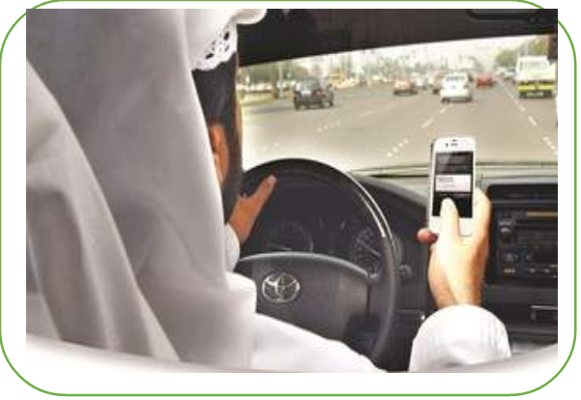**( car accidents – use mobile – drive –sleeping –follow- traffic rules)**

**Plan your topic here**





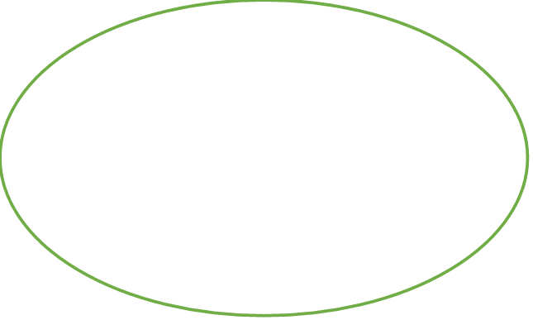







**Write your topic here**

………………………………………………………………………………………………………………………………………………………………

………………………………………………………………………………………………………………………………………………………………

…………………………………………………………………………………………………………………………………………………………….

…………………………………………………………………………………………………………………………………………………………..

…………………………………………………………………………………………………………………………………………………………..

………………………………………………………………………………………………………………………………………………………………

………………………………………………………………………………………………………………………………………………………………

……………………………………………………………………………………………………………………………………………………………