Grade 77777777777777 Unit ( 1 ) Family and Friends

 | Words | Meanings
1 | Hip | عظمة الورك
2 | Operation | عملية
3 | Wheelchair | كرسي متحرك
4 | Limit | يحدد
5 | physically challenged | معاق بدنيا

A) Fill in the spaces with words from the list:

hip – operation – delicious – wheelchair – physically challenged

He can't move by himself. He needs a …………………………………to move.
All people have to help the ……………………………….people.
He broke his ………………in a car accident last week.
After the accident, he had to have a/an ………………………..in the hospital.

Choose the correct word from a, b, c and d:
There are many …………of information like the internet, books and TV.
adventures - attics - operations -sources
My favourite films are ………………….. and action films.
source - attic - adventure - Inuit
I keep all my old things and pictures in the ………………. in a wooden box.
operation -attic -hip -source
………………. people live in igloos in the North Pole.
Wheelchair -Source -Inuit - Operation

The possessive ('S)

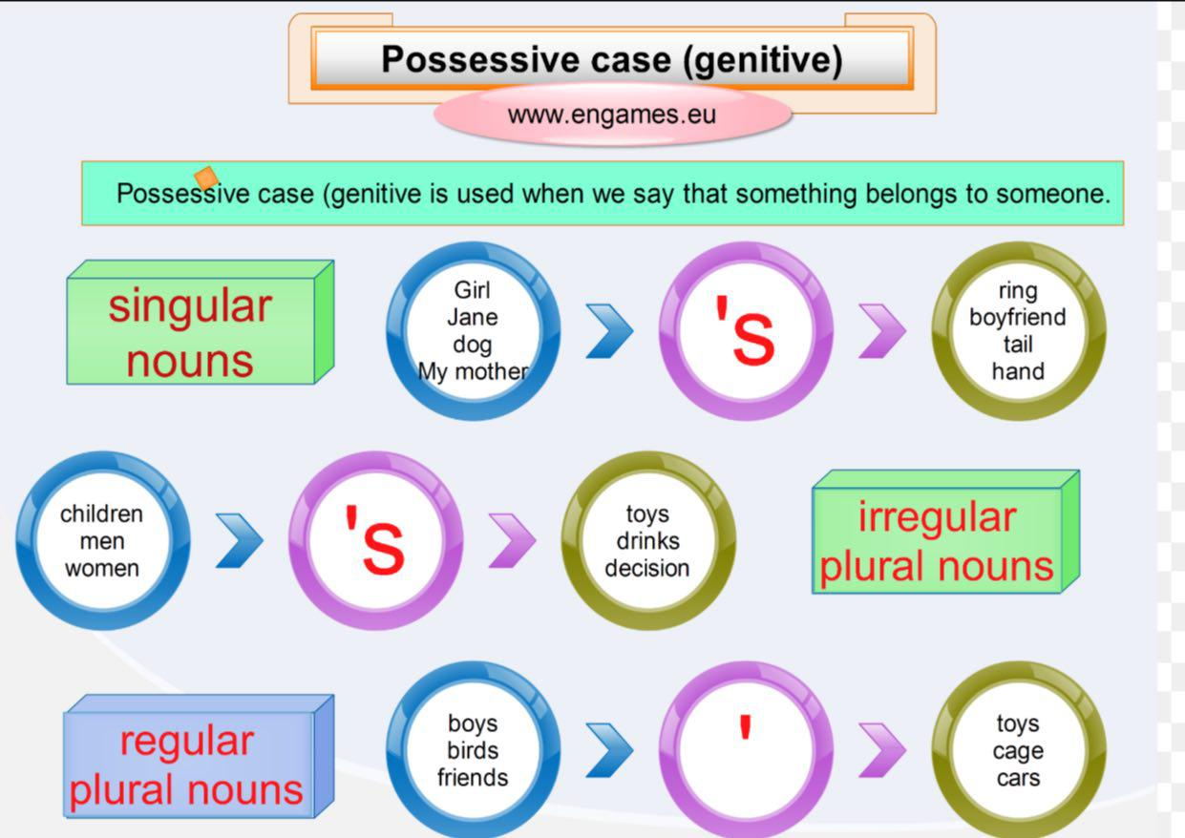
We use apostrophe before and after S ending of nouns
's : 1. This is Ali's car. ( Ali is singular)
2. I met the boy's father. (One boy)
S' : I met the boys' fathers. ( many boys )

A )Choose the correct answers:-
The ( girl's – girls' – girls ) mother is happy with them. One of them showed her father her English (teacher – teacher's – teachers' ) good remarks. When they were rewarded, the girls were pleased by their (father – father's – fathers' ) nice presents.

Verb to be
I am a doctor. = I'm a doctor.
He is a teacher. = He's a teacher.
She is my sister. = She's my sister.
It is a nice cat. = It's a nice cat.
They are nice friends. = They're nice friends.
You are a pupil. = You're a pupil.
We are good at English. = We're good at English.

A) Choose the correct answers to finish the paragraph:-
My family ('s –'ve – 'm) small. My father ('m –'s –'re) a doctor. My mother ('m –'s –'re) a teacher. My brother and sister (am –is –are) in primary school. I ('m –'s –'re) in grade seven.

B) Do as shown in brackets:-
1- They ( be ) ………….……………in the same class. ( correct )
2- I ( be ) ………….……………quite good at sports. ( correct )
3- The film is quite interesting. ( negative)
………………………………………………………………………………..

Grammar
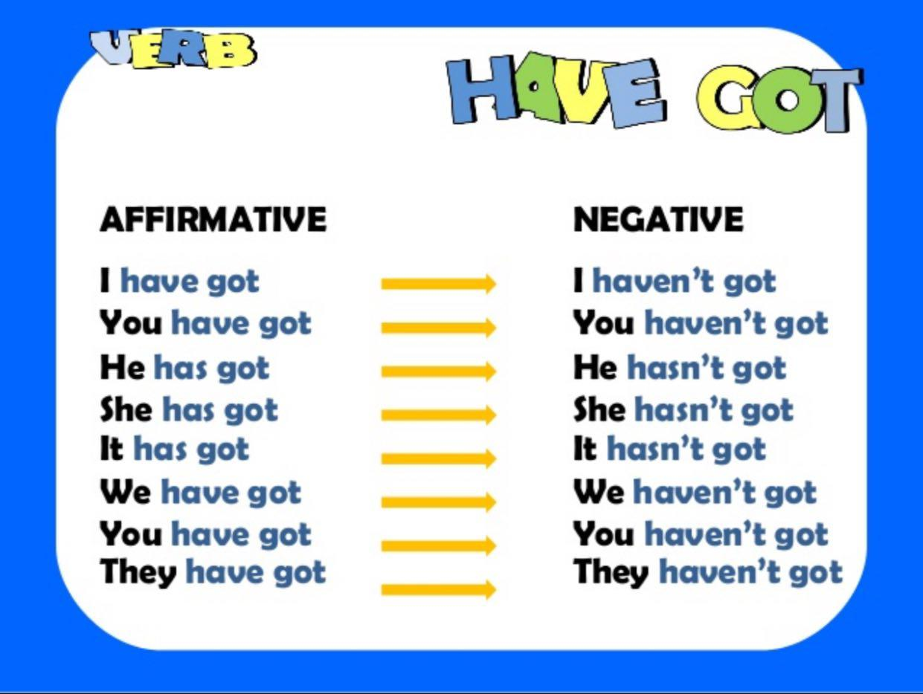

A: I have got a mobile phone. B: So have I .
A: I haven't got a mobile phone. B: Neither have I .

Choose the correct answer:

I ( have got – has got – has ) two brothers who are older than me . Salem, the elder brother
( have got – has got – have ) a pet cat. It (have got – has got – have ) a long tail. We all
( have got – has got – has ) pets.

My friend ( have – has got – have got ) a personal stereo and ( so – neither – either) have I . However, he ( haven’t got – hasn’t got – don’t have ) a DVD player and (so – neither – either) have I .
B- Do as shown:
They have got some interesting computer games.
( Negative )

……………………………………………………………………………………
Ahmad (have got) a new webcam.
( Correct )
……………………………………………………………………………………
I have got two sisters.
( make a question) ……………………………………………………………………………..

Words
Spacious | واسع – فسيح
Temporary | مؤقت
Inuit | متنقل
Especially | خاصة
Against | واسع – فسيح
eco-friendly | صديق للبيئة
Source | مصدر

Choose the correct word from a, b, c and d:
The hot weather is just ………………………..and it will be fine again.
spacious d- - temporary c b- delicious a- challenged

Salem is good at sports……………………… basketball.
initially d- - physically c - against b a- especially
The ……………… are people who live in the Arctic.
hip d- - Inuit c - operation b a- source
Fill in the spaces with words from the list:-

hip – spacious –delicious – eco-friendly – source

Our house has got a ………………………garden where we can play and run.
Rain is an important …………………………..of water in our country.
This is a / an ……………………………….car. It does not harm the environment.
My mother always cooks ………………….. food.

Reading Comprehension
Read the following passage carefully, then answer the questions below:

Mr. Ahmed was a hardworking father who has got a wife and three children. He spent all his evenings after work attending classes, hoping to improve himself so that he could one day find a better paying job. He worked and studied very hard because he wanted to have a better life. Whenever the family complained that he was not spending enough time with them, he reasoned that he was doing all this for them. Then, he passed his exams with high degrees! Soon after, he was offered a better job in a big company. 'Like a dream come true', father could now provide his family with life's needs like nice clothing, fine food and travelling.
As expected, Mr. Ahmed's hard work paid off again and he bought a beautiful villa overlooking the sea. On the first Sunday evening at their new villa, Mr. Ahmed said to his family that he decided not to take any more courses and he was going to spend more time with them.
a )-Choose the best answers from a, b, c and d:

1. The main idea of the passage is …………………….
a) the importance of learning b) the importance of travelling
c) the importance of company d) the importance of the sea

2. The underlined word" provide" in the 7th line means……..…………
a) decide b) said c) give d) take

3. The underlined pronoun "them" in the last line refers to Mr. Ahmed's………….
a) courses b) classes c) children d) family

4. The writer's purpose is to show that ……………………………………………
- it is important to sit with your family b) it is important to earn money
c) it is good to live alone d) you don’t have to work
5. 6. Mr Ahmed's family consists of …………………..people.
a) three b) five c) six d) seven
6. Mr Ahmed studied hard to ………………………… .
a) spend time with his family. b) have a better life.
c) teach his children d) travel to another country.
b )-Answer the following questions :
7. Where does Ahmed's family live now ?
………………………………………………………………………………
8. What do you think of Mr. Ahmed?
………………………………………………………………………………

Writing
Plan and write an article of two paragraphs (not less than 10 sentences) about
" Your Ideal Home ".
- These guide words may help you:

( nice – large – has got - bedrooms – spacious - garden – favourite– like)

Write your topic here!
"My Ideal Home "
…………………………………………………………………………………………………………………………………………………………………………………………………………………………………………………………………………………………………………………………………………………………………………………………………………………………………………………………………………………………………………………………………………………………………………………………………………………………………………………………………………………………………………………
…………………………………………………………………………………………………………………………………………………………………………………………………………………………………………………………………………………………………………………………………………………………………………………………………………………………………………………………………………………………………………………………………………………………………………………………………………………………………………………………………………………………………………………
…………………………………………………………………………………………………………………………………………………………………………………………………………………………………………………………………………………………………………………………………………………………………………………………………………………………………………………………………………………………………………………………………………………………………………………………………………………………………………………………………………………………………………………
…………………………………………………………………………………………………………………………………………………………………………………………………………………………………………………………………………………………………………………………………………………………………………………………………………………………………………………………………………………………………………………………………………………………………………………………………………………………………………………………………………………………………………………
…………………………………………………………………………………………………………………………………………………………………………………………………………………………………………………………………………………………………………………………………………………………………………………………………………………………………………………………………………………………………………………………………………………………………………………………………………………………………………………………………………………………………………………
………………………………………………………………………………………………………………………………………………………………………………………………………………………………………………………………………………………………………………………………………………………………………………………………………………………………………………………………………………………………………………………………………………………………………………………………………………
Spelling
Re-write the underlined words correctly:
We have got a spaicuos attic at our house…………………………………………….
An igloo is a tmeporray home for the people in the Arctic. ……….…………………
My mother always keeps the old things in the atitc……………………………………
We should use eco- freinldy cars……………….…………………………………….

