2017

-

2018

Ministry of Education
Grade 1
0

Ahmadi Educational Area

Abdullah Al-Ahmad Al-Sabah Secondary School

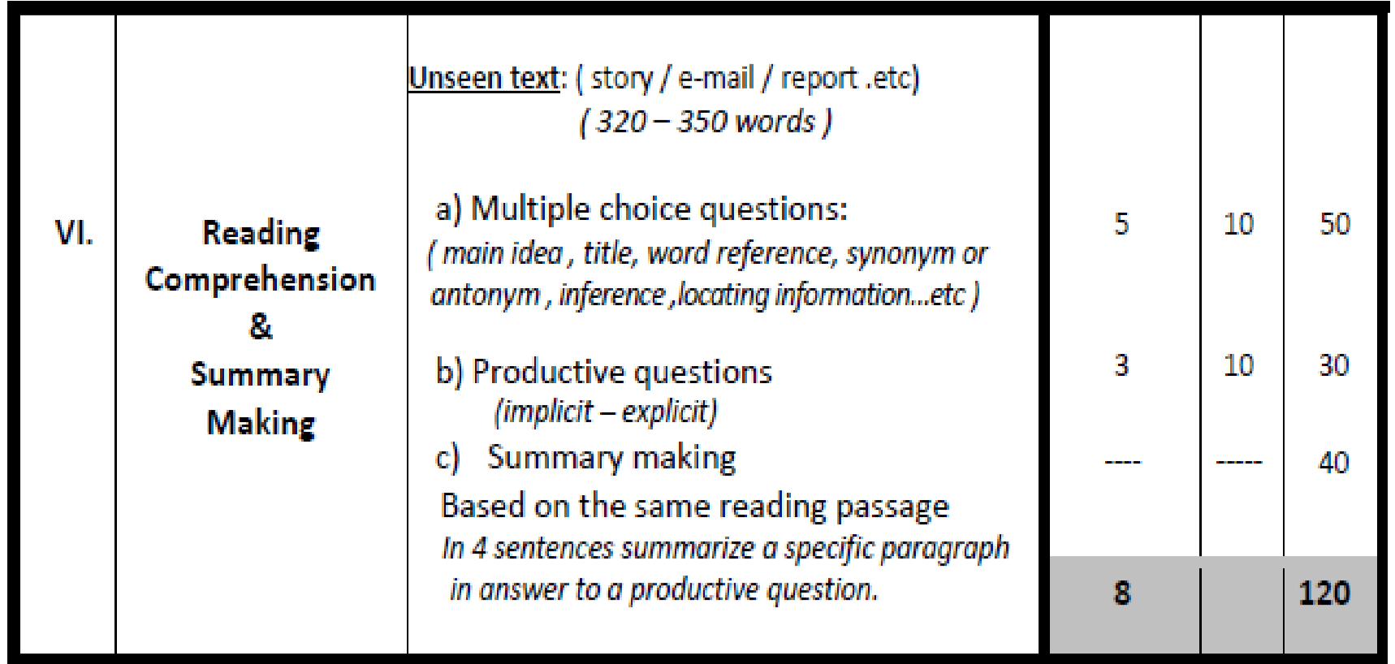
Mr. Niazi Abdelaziz TRIKI

Grade 10
Reading Comprehension (120 Marks)
- Sally was only eight years old when she heard her parents talking about her little brother, Georgi. He was very sick, and they had done everything they could afford to save his life. Only a very expensive surgery could help him now, and that was out of the financial question. She heard Daddy saying, "only a miracle can save him now."
- Sally went to her bedroom and pulled her moneybox. She shook all the change out on the floor and counted it carefully. Three times. The total had to be exactly perfect. No chance here for mistakes. She left the apartment and made her way to the pharmacy.
- "What do you want?" the pharmacist asked in an annoyed tone of voice.
"Well, my brother is sick, and I want to buy a miracle." "I beg your pardon," said the pharmacist.
"My Daddy says only a miracle can save him now. So how much does a miracle cost?"
"We don't sell miracles here, little girl. I can't help you."
"Listen, I have the money to pay for it. Just tell me how much it costs."
A tear started down her cheek. "I just know he's really sick and Mommy says he needs an operation. But they can't pay for it. So I have my money." "How much do you have?" Asked the well-dressed man.
"A dollar and eleven cents," Sally answered proudly. "And it's all the money I have in the world."
He felt sorry for her. "Well, what a coincidence!" Smiled the well-dressed man.
"A dollar and eleven cents . . . the exact price of a miracle to save a little brother." He stooped down. He held her hand and said, "take me to where you live. I want to see your brother and meet your parents."
4- That well-dressed man was Dr. Carlton Armstrong. The operation was completed with no charge. It wasn't long until Georgi was home again and doing well. "That surgery," Mommy whispered. "It's like a miracle. I wonder how much it would have cost." Sally smiled to herself. She knew: just one dollar and eleven cents plus the faith of a little child.

I- Choose the correct answer from a, b, c and d: (5 x 10 = 50 M)

1- The writing type of the text is ……………………………………...……………………………...…. a. narrative
- persuasive
- informative
- argumentative

2- The opposite (antonym) of the underlined word "annoyed" is …………………………………..... a. angry
- pleased
- irritated
- bad-tempered

3- The underlined word "that" in paragraph 1 refers to ……………………………… a. life
- surgery
- question
- everything

4- All the sentences below are not true except: a. Sally didn’t care for her brother’s illness.
b. The parents paid a lot of money for Georgi’s operation. c. The parents did their best to find a solution to save their son
d. After the surgery, Georgi suffered from health complications.

5- The proverb that can describe Sally's attitude is ……………………………………. a. East or west, home is the best.
- Forgiveness is the best revenge.
- Silence is the source of great strength
- You don't have to be rich to be generous
II- Answer the following questions: (3 x 10 = 30 M) 6- How much did the miracle cost?
……………………………………………………………………………………………………………..

- Why did Sally resort to her moneybox?
……………………………………………………………………………………………………………..

- Pick the information that shows the peak of sally's desperation.
……………………………………………………………………………………………………………..

III- In four sentences of your own, summarize paragraphs 3 showing the pharmacist’s actions which reflect his kindness: (4 x 10 = 40 M)

……………………………………………………………………………………………………………
……………………………………………………………………………………………………………
……………………………………………………………………………………………………………

