2017

-

2018

Ministry of Education
Grade 12

Ahmadi Educational Area

Abdullah Al-Ahmad Al-Sabah Secondary School

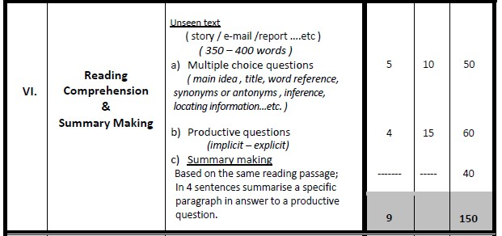
Mr. Niazi Abdelaziz TRIKI

Grade 12
Reading Comprehension (150 Marks)
- Clarence Lundberg’s thought he would never stop smoking. After all, wouldn’t quitting smoking after 45 years be impossible? Clarence started smoking when he was only 12 years old, and got used to waking up in the morning and starting his day with a cup of coffee and a cigarette.
- So why did Clarence decide to take the big step toward quitting tobacco? “It all started in 2011, when I went to the doctor for a regular check-up. I was lucky to be asked if I wanted to take part in a lung test program, and this is when I was diagnosed with chronic disease,” he said. “I was concerned when the research doctor told me I could continue to keep smoking, but I would need an oxygen tank next to the bed in a year or two. That’s something my wife, would definitely not find attractive.”
- Clarence is a success story. Through the Smoking Cessation Program, he has now been smoke-free for over a year and a half. “When the doctor told me I was facing a future with an oxygen tank, I tried to quit smoking straight away. And I did quit, but I realized I needed more support and help when I relapsed and began smoking again. I took steps to quit with the Smoking Cessation Program and used the nicotine patches and the coaching programs. I liked the patches in particular, as they took away my craving for a morning cigarette.”
- The future looks brighter and clearer for Clarence, who experienced a multitude of benefits once he stopped smoking. He used to wake up in the morning with a persistent cough, sometimes coughing for over five minutes straight. “Before I quit smoking, I wouldn’t have believed how much healthier I could feel. My circulation got much better—my hands and feet have colour and are warm instead of white and cold. I don't have an oxygen tank next to the bed and my morning cough is gone. I have much better energy in the morning, and I can easily swim 2,000 metres and close to 20 metres under water.”

I- Choose the correct answer from a, b, c and d: (5 x 10 = 50 M)

1- The text is mainly about a man who ………………………………………………………………….…... a vainly tried to quit a 45-year smoking experience.
- willingly gave up smoking thanks to a doctor’s support.
- was determined enough to voluntarily quit smoking. d. has never quitted smoking as he is a smoking addict.

2- The underlined word "something" in paragraph 2 refers to ………………………………………….. a. going for a regular check-up
- taking part in a lung test program
- taking the big step toward quitting tobacco
- having an oxygen tank next to the bed in a year or two

3- The synonym of the underlined word "smoke-free" in paragraph 3 is ……………………………… a. non-smoker
- heavy smoker
- smoky flavour
- passive smoker

4- All the sentences below are not true except:
- Clarence discovered his chronic disease after marriage
- Clarence has never reversed his decision to quit smoking
- Clearance's doctor asked him to stop smoking immediately
- Clarence asked the doctor to take part in a lung testing program

5- After quitting cigarettes, ………………………………………………………………………………. a. Clarence was much healthier
- Clarence's body parts looked unhealthy.
- Clarence was diagnosed with a chronic disease
- Clarence used to wake up in the morning with a persistent cough

II- Answer the following questions: (4 x 15 = 60 M)

- How long has it been since Clarence quitted smoking?
……………………………………………………………………………………………………………..…….

- How old was Clarence when he quitted smoking for good?
……………………………………………………………………………………………………………..……..

- What did Clarence do to find support in his quit-smoking process?
……………………………………………………………………………………………………………..……..

- Why did Clarence favour the nicotine patches over the Smoking Cessation Program?
……………………………………………………………………………………………………………..……..

III- In four sentences of your own, summarize the last paragraph showing the benefits Clarence gained after quitting smoking: (4 x 10 = 40 M)

…………………………………………………………………………………………………………………..
…………………………………………………………………………………………………………………..
…………………………………………………………………………………………………………………..
…………………………………………………………………………………………………………………..

