Save endangered animals
Introduction :
- Did you ever thought how many animals die ever day ?

Body 1 :
- The causes of extinction .
- Human ability to interfere in the death of animals .

Body 2 :
- Ways to prevent or reduce animal extinction
- Human actions that can help animals

Conclusion :
- Maintain reassurance and peace .

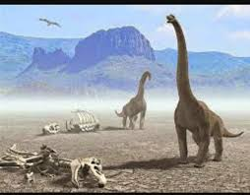
Save endangered animals
Have you ever thought about the number of animals that die every day and are threatened with extinction ? for reasons most of them are human ? I will talk in my paragraph about its causes and how we can control it .
And of course, animals don’t become extinct without a reason, and I believe most of them are by humans, and one of the most important of these reasons is the loss of habitat. When a person cuts down trees, the animals that live in the trees will lose their home, as well as overfishing. It is difficult for animals to reproduce.
Since most of the causes of the extinction of animals are due to man, then it is certain that there are ways in the hand of man to reduce the extinction of animals. First of the most important of these methods is the responsibility to buy. There is a group of people with superficial thinking that may buy products made from animal skins or even their parts. People stop buying these things, this will affect the decrease in the number of number of animals that are threatened with extinction, and also the donations and donations may be money to zoos, and it may also be time, for example volunteering time to clean the beaches, and there are many volunteers from people helping animals.
In the conclusion, I will say that we must maintain peace and tranquility in the life of animals, and a person can’t be selfish to the point of living in the universe alone. We can’t imagine the universe without animals, so let us preserve the relationship between living beings .

