**CHAPTER 9 LESSON SUMMARY**

**LESSON 1 AIR AND WEATHER**

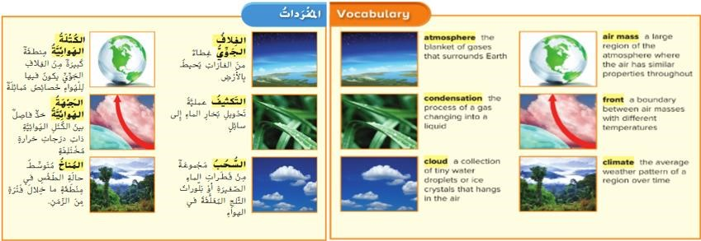

**P: 456_457**

**· What are Layers of Earth’s Atmosphere?**

The atmosphere is a blanket of air that surround Earth

The atmosphere is made up of gases -Oxygen and nitrogen

The atmosphere allows living things to survive on Earth

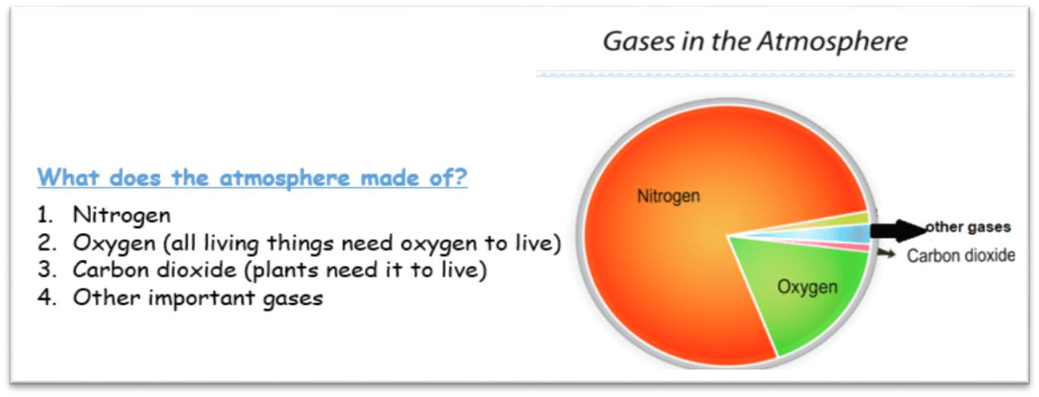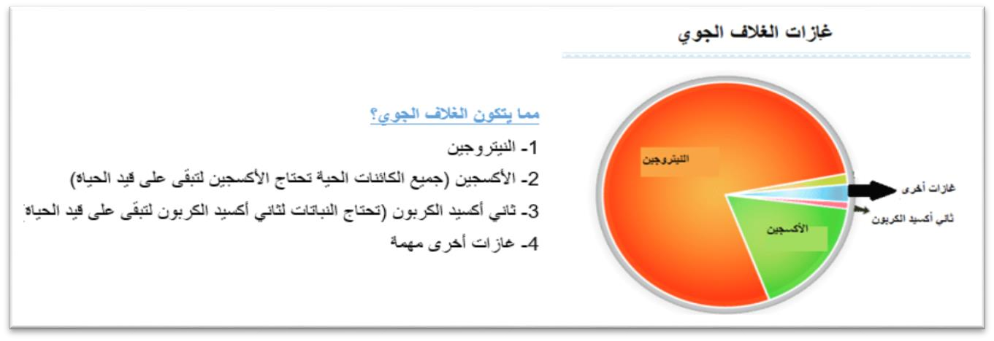

**LAYERS OF THE EARTHS ATMOSPHERE**

* troposphere Closest to Earths surface
* stratosphere
* mesosphere
* thermosphere

|  |  |
| --- | --- |
| **1- Troposphere التروبوسفير** | -The closest to Earth’s surface  -Very thin  -All the Earth’s life exists in troposphere  -Earth’s weather takes place in the troposphereا  -**Wind** is the air that moves from place to place  -Wind can be gentle as a light breeze    -Wind can be as fierce as a tornado    -Any change in wind brings a change in the weather |
| **2- Stratosphere الستراتوسفير** | -It is the layer above the troposphere  - It has fewer air particles |
| **3- Mesosphere الميزوسفير** | The air is lighter than the one stratosphere |
| **4- Thermosphere الثيرموسفير** |

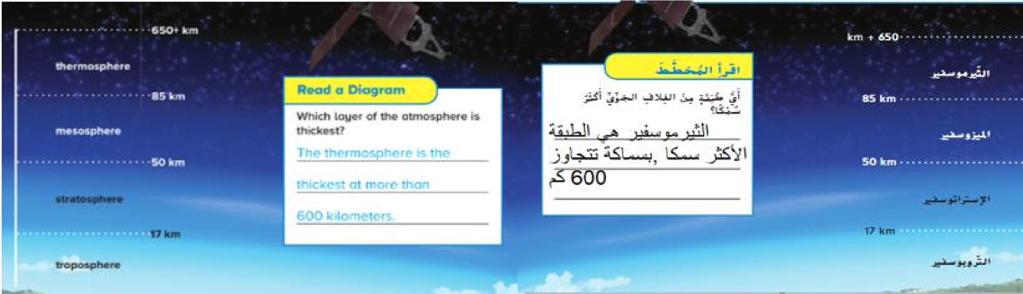

**P: 458_459**

**· What is weather?**

Weather is the condition of the atmosphere at a given time and place

|  |  |  |
| --- | --- | --- |
| **Air Temperature درجة حرارة الهواء** | - | **Temperature** : Describe how hot or cold something is |
|  | - | Sun’s energy heats the surface of Earth--->the surface heats the air above it---> The air moves |
|  | - | The uneven heating of Earth’s surface causes air to move at different speeds---> Moving air is called wind |
| **Humidity الرطوبة** | - | **Humidity** is a measure of how much moisture is in the air |
|  | - | Most of moisture comes from ocean water that changes into gas |
|  | - | The rest of humidity comes from bodies of water, soil, and plants |
|  | - | Deserts have very low humidity |
|  | - | Rain forests have very high humidity |
| **Air pressure ضغط الهواء** | - | **Air pressure** is the force of air pushing on an area |
|  | - | Cool air weights more than warm air because the particles are closer together in the same amount of space, so it has more dense (more pressure) |
|  | - | Warm air is less dense than cold air (less pressure) |
|  | - | Air moves from high pressure area to low pressure area |
| **Precipitation الهطول** | - | **Precipitation** is any form of water that falls from clouds **الهطول** |
|  | - | Precipitation includes rain, snow, sleet, and hail. |

**P: 460**

**· How can you measure weather?**

We use tool to measure weather

**Hygrometer**- measures humidity

**thermometer**- measure temperatures in degrees Celsius or degrees Fahrenheit

**barometer**- measures air pressure

**Rain gauge**- shows how much rainfall

**Wind Vane-** shows the direction that the wind is blowing

**Anemometer-** measures wind speed

|  |  |
| --- | --- |
| Humidity الرطوبة | Hygrometer  الهيجروميتر |
| Air Temperature درجة الحرارة | Thermometer  ميزان الحرارة - الثيرموميتر |
| Pressure الضغط | Barometer  الباروميتر |
| Rain fall هطول المطر | Rain gauge مقياس المطر |
| Wind direction  اتجاه الرياح | Wind vane  دوارة الرياح |
| Wind speed سرعة الرياح | Anemometer  مقياس شدة الرياح |

|  |  |
| --- | --- |
| **VOCABULARY CHAPTER 9 LESSON 1** | |
| humidity رطوبة | how much moisture is in the air |
| air pressureضغط جوي | force of air pushing on an area |
| precipitationترسب | any form of water that falls from clouds. rain. snow. hail, sleet |

**CHAPTER 9 LESSON SUMMARY**

**LESSON 2 WATER**

**P:470_471**

**· Where is Earth’s water found?**

|  |  |
| --- | --- |
| Salt water الماء المالح | * Oceans have salt water. This water cannot be used for plants or for drinking * there is TOO much SALT in the water. |
| Fresh water المياه العذبة | * Freshwater- this is water without much salt. Rivers. Lakes, ponds. * Glaciers and icecaps hold most of earths water |
| Below ground | * Groundwater- water that is fills cracks in rocks * Soil water- water that soaks into soil * Plants use some of it |
| Watershed | * Watershed- water flows downhill into a stream, lake or river |

|  |  |
| --- | --- |
| **VOCABULARY CHAPTER 9 LESSON 2** | |
| Soil water مياه التربة | water that soaks into soil  تتسرب المياه الي التربة |
| Groundwater- المياه الجوفيه | water that is fills cracks in rocks  هي المياه التي تملا الشقوق وفراغات الصخور تحت الارض |
| Watershed المستجمعات المائية | - water flows downhill into a stream, lake or river  هي تتدفق المياه على سطح الارض الي اسفل منحدر او الي مجرى مائي او بحيرة او نهر |

**· How is freshwater is supplied?**

|  |  |
| --- | --- |
| **RESERVOIRS-خزانات مائية**  **An area for holding and managing water e.g some are lakes and pond. Some are created by people**  **Pipelines supply the water from here to the people.** | **C.W. Bill Young Regional Reservoir Renovation Project, Florida ...** |
| **Wells: ألأبار**   * **Groundwater is another source of freshwater.** * **A well is the most common way of getting groundwater. Wells are deep holes drilled or dug below the ground.** * **Pumps get the water to the surface.** | **Water Well Images, Stock Photos & Vectors | Shutterstock** |

**How else do we use water?**

**P:474**

* **Farming- Irrigation is a way to bring water into the soil through pipes or ditches.**
* **It is used to generate electricity.**
* **Ships need water to transport goods.**
* **Swimming, boating, and fishing are some of the many examples.**

**CHAPTER 9 LESSON SUMMARY**

**Lesson 5 CLIMATE**

**P:**

**· What is climate?**

* The pattern of weather that happens year after year.
* Climate is not the same everywhere on Earth

**What are Climate Regions?**

* A place that has similar humidity, temperatures and wind

|  |  |
| --- | --- |
| Polar climate (Antarctica)   * Cold climate * Low precipitation |  |
| Temperate climate (Canada)   * Temperate climate often has the four seasons. |  |
| Tropical climate   * Warm * Humid * Rainy |  |
| Dry climate (Al Ain)   * Warm and dry all year * Snow and rain rarely fall. |  |
| Cool climate   * COLD |  |

**· What determines climate?**

**P:515_516**

* **Latitude**- How far a place is from the equator
* **Global Winds**- Winds that move air between equator and the poles/
* **Ocean currents**- a current is a directed flow of gas or a liquid.
* Some currents move warm water from the equator the poles
* Others move cold water from the poles to the equator
* **Distance from Water**-Being near or far water affects climate. Places that are nearer to the water have cooler summers, warmer winters and have more rain

**· How do mountains affect climate?**

* The base of a mountain is always warmer than its peak. The higher the altitude, the lower the temperature. As the air goes higher it gets cooler.
* ALTITUDE- how far above sea level a place is

|  |  |
| --- | --- |
| Climate المناخ | The pattern of weather that happens year after year.  هو نمط الجو الموسمي الذي يحدث عاما تلو الاخر |
| Current تيارات | a current is a directed flow of gas or a liquid  التيار هو التدفق الموجه للغاز أو السائل |
| Altitude  ارتفاع عن سطح البحر | How far above sea level a place is  مستوى الارتفاع عن سطح البحر |
| Latitude  خط العرض | How far a place is from the equator  مدى بعد المكان عن خط الاستواء |
| Global winds  رياح عالمية | Winds that move air between equator and the poles  الرياح التي تحرك الهواء بين خط الاستواء والقطبين |
| **ESSENTIAL QUESTION- WHAT IS THE DIFFERENCE BETWEEN WEATHER AND CLIMATE?**  Weather is the condition of the atmosphere at a given time and place  الطقس هو حالة الجو في وقت ومكان معينين  Climate is the pattern of weather that happens year after year  المناخ هو نمط الطقس الذي يحدث سنة بعد سنة | |