Name ______________________ Grade 9 A
Marks 10 Time: 40 Min
- Parallel lines are coplanar lines and that do not ________________ 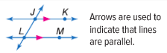
- Not skew b) Intersect c) skew d) None [ ]

- 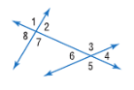

- Alternate exterior angles b) Alternate interior angles c) corresponding d) None [ ]

- Corresponding b) vertical angles c) Alternate angles d) none [ ]

- 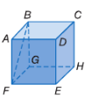

- b) c) d) None [ ]

- 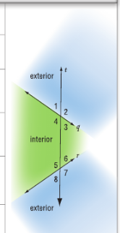
- 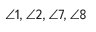 b) c) 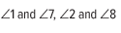 d) None [ ].

