Al Foaa School | Math Grade 6  Quiz 4 Review | T3  2018-2019

- What is the area of a square ?  (1) | - What is the area of a triangle:  (1)
3. Calculate the Surface area of the square pyramid below:  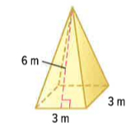  (4) | 4. Calculate the volume of the pyramid below:  The height of the pyramid is 5m.  (4)
 | Total: $\frac{}{10}$

