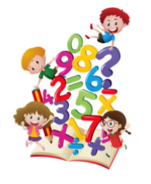

Question One: Write the totals. Use the chart to answer the questions

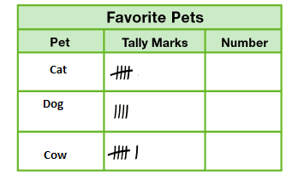

- How many people like Dog? ______

- How many people like cow? ______

- How many more people chose cow than dog? _______

- Which pet has more votes than cat? ________

- Did fewer people choose cow or dog? ________

- How many people were surveyed? _______

- How many people chose cat and dog? ________

- Use the tally chart to make picture graph.

Favorite pets
Cat
Dog
Cow

- Use the tally chart to make bar graph.

Favorite pets
Cat
Dog
Cow

Question Two: Compare. Circle the shorter object.

1.

2.

Question three: Order the objects by length.

- Write 1 for short 2 for shorter, and 3 for the shortest.

______________ ______________ ____________

- Write 1 for long, 2 for longer, and 3 for the longest.

____________ ____________ ____________

- Laila has a box, a pencil, and a marker. The box is longer than the pencil. The pencil is longer than the marker. Is the marker longer than or shorter than the box?

Longer than shorter than

Question four: Tell what time is shown. Write the time.

- 2.
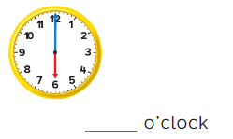
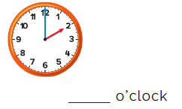

3. 4.
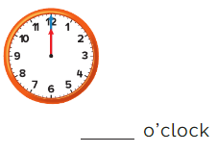
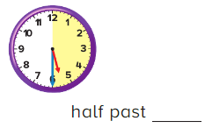

5. 6.
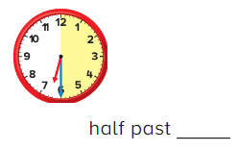
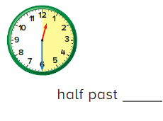

Question five: Tell what time is shown. Write the time on the digital clock.
1. 2.
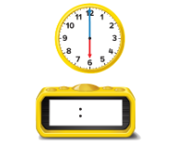
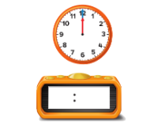

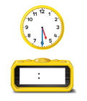
3. 4.
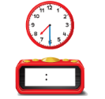
5. 6 o’clock 6. Half past 1

Question six: Ahmad has football practice at 5. It lasts 1 hour what time does football practice end?
__________

Question seven:
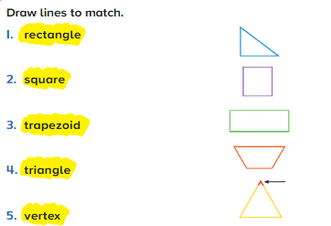

Question eight: write how many sides and vertices.
- 2.

_______ Sides _____ Sides
_______ Vertices _____ Vertices

3. 4.

______ Sides ______ Sides
______ Vertices ______ Vertices

6. 7.

______ Sides _____ Sides
______ Vertices _____ Vertices

Question nine: Write how many equal parts make up the whole.

1. 2.

_____ equal parts _____ equal parts
______ Quarters _____ halves

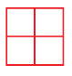
3. 4.

______ equal parts
______ equal parts ______ fourths
______ halves
Question ten: I am a two-dimensional shape that has more than two but less than 4 sides. What shape am I?
_______________

Question eleven: Identify each shape. Circle the name. write the number of faces and vertices.

Cube Cone
_______ faces _______ vertices

Rectangular prism Cylinder
_______ faces _______ Vertices

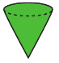
Cube cone
______ faces _______ vertices

rectangular prism Cube
______ faces _____ vertices

Question twelve:
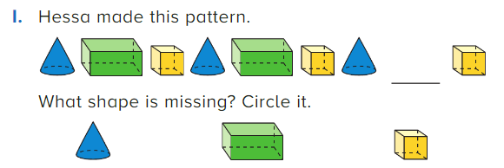

Good luck

