- Chose the correct answer of the following questions.
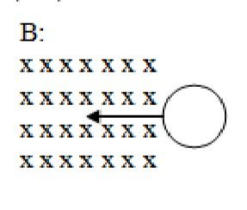
- What is the direction of the induced current that produced in the loop shown in the figure, at the instant that the loop Enters the constant magnetic field B.

  - Clockwise.
  - Counterclockwise.
  - Out of the page.
  - No induced current will produce.

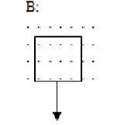
- What is the direction of the induced current that produced in the rectangular loop shown in the figure, at the instant that the loop leaves the constant magnetic field B.

  - Clockwise.
  - Counterclockwise.
  - Out of the page plane.
  - Inside the page plane.

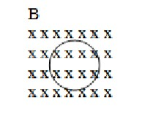
- What is the direction of the induced magnetic field that produced in inside the loop shown in the figure, if the magnitude of the magnetic field B is increasing?

  - Inside the page plane.
  - Outside the page plane.
  - To the right of the page plane.
  - No induced magnetic field will produce.

- What is the direction of the induced current produced in the loop shown in the figure?

↑ | → | ↓
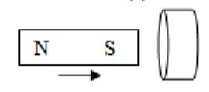
←

  - B C D
- What is the direction of the induced current through the resistor R in circuit B, if the magnitude of the variable resistor in circuit A is decreased?
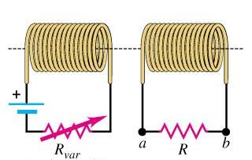
A

B

  - From a to b
  - From b to a
  - Oscillating between a and b
  - No induced current will produce.

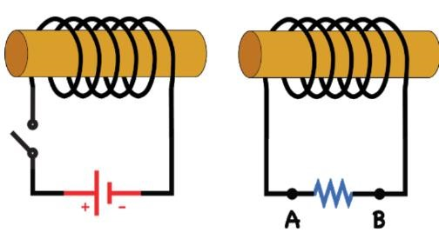
- What is the direction of the induced current through the resistor in circuit B, at the instant of turning on circuit A.
A

B

  - From A to B
  - From B to A
  - Oscillating between A and B
  - No induced current will produce.

- Determine the direction of the eddy currents that produced in the rectangular piece of metal shown in the figure, at the instant of entering the constant magnetic field B.
𝑣
Ԧ

𝐵
ሬ
Ԧ

  - Inside the plane of page.
  - To the right of the plane of page
  - Counterclockwise
  - Clockwise

- A magnetic field changing with time, [𝑩(𝒕) = 𝟔. 𝟐 𝒕^{𝟐}] passing through a rectangular wire loop with (3 cm length and 2 cm width), if the angle between the magnetic field and the loop is 30 deg ֯what is the magnitude of the induced potential difference in that loop at t= 3 s?

- 0.2 V
- 1.3 V
  - 6.7 V
  - 0.01 V

- The graph represents the changes of the current during a different time interval in an inductor with inductance of 10 𝒎𝑯, what is the
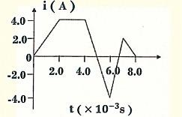
magnitude of the maximum induced potential difference in the inductor during the intervals shown in the graph?

  - 20 V
  - 40 V
C. 60 V
D. 80 V

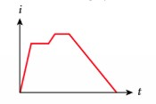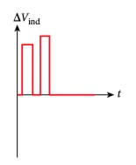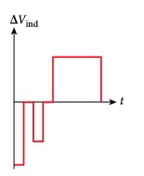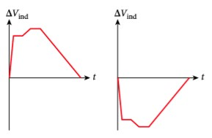
10
-

A graph of the current
𝒊

through
loop (A)

as a
function of time, t, is shown in the figure. Which
graph best describes the induced potential
difference

as a function of time
,

in
loop (B)
located near loop A
?

A

B

C

D

