- Chose the correct answer of the following questions.
- When we close the switch of the circuit shown in the figure, the electric current and the potential difference will oscillate through the circuit, which physical quantity represented by axis Y in the graph that related to the same circuit?
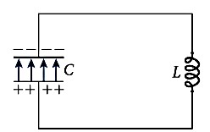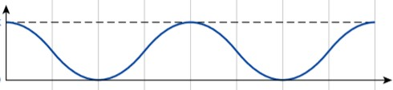

Time

𝑦

  - The charge between the capacitor plates.
  - The current intensity that passes through the circuit.
  - The energy stored in the electric field,
  - The energy stored in the magnetic field.

- What is the magnetic energy stored in a coil with 0.3 𝒎𝑯 inductance when 2.3 A DC current passes through it?

  - 1.5 J
Ub=1\2 L i^2=
1/2(0.3x10^-3)(2.3)^2=
7.9x10^-4 J

  - 0.79 J
  - 3.6 J
  - Zero

- When does the current reach its maximum value In the LC circuit shown in the figure?
- When the capacitor is fully charge.
- When the capacitor is empty.
- When the energy stored in the circuit is zero.
- When the energy stored as a magnetic field is zero.

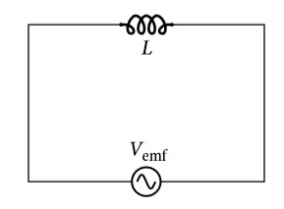
- In the circuit with an inductor shown in the figure which of the following statements is correct about the phase difference between the current and the voltage?

  - The current lead the voltage with ∅ = 𝜋/2
  - The current lags behind the voltage with ∅ = 𝜋/2
  - The voltage lags behind the voltage with ∅ = 𝜋/2
  - The voltage and the current are in phase.

- A series RLC circuit contains a 100.0 Ω resistor, a 0.50 H inductor, and a capacitor, the source of time-varying emf frequency is 420 rad/s, rely on the phasors of the voltage to find the capacitance.
  - 1.1×10⁻⁵ F
  - 3.4×10⁻⁵ F
  - 6.2×10⁻⁵ F
  - 5.9×10⁻⁵ F

- From the series RLC circuit shown in the figure find the following:
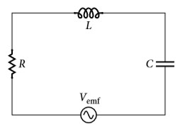
L=12 𝒎𝑯
𝑽
𝒓𝒎𝒔
=120
V

R= 20 Ω C= 6.2 µF

𝝎=315 rad/s

- The inductive reactance.
Xl=WL
Xl=(315)(12x10^-3)=3.78
The capacitive reactance.

Xc=1/Wc
Xc=1/(315)(6.2x10^-6)=512.03
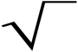
- The impedance
Z=
R^2 + (Xl-Xc)^2
Z= 508.64
- The phase constant
@=tan^-1(Xl-Xc/R)
@=Tan^-1(3.78 - 512.03)

- The current in the circuit
I=V/Z
120/508.64=0.24 A
- The voltage through the capacitor
Vc=iXo
Vc=(0.24)(512.03)=122.88 v

