A - Put in the correct verb form.

- We making sandwiches.
- am
- are
- is

- I sending a text message.
- am
- are
- is

- Tom cleaning the shop.
- am
- are
- is

- They doing an exercise.
- am
- are
- is

- The teacher checking the homework.
- am
- are
- is
- My friends watching a new DVD.
  - am
  - are
  - is

- George wearing a jacket today.
  - am
  - are
  - is

- Ronny and David running out of the house.
  - am
  - are
  - is

- My baby brother playing with his toys.
  - am
  - are
  - is

- Our class visiting a museum.
  - am
  - are

Teacher: Rana Almoukdad

B – Change the following sentences to negative.
1) The girls are riding their bikes.
2) He is taking out a book.
3) I am washing my hair.
4) The baby is crying.

C - Change the following sentences to question.
1. You are listening to music.
2. The dog is running after the cat.
3. She is sitting on the chair.
4. My mum is preparing lunch now.
5. We are carrying buckets.
6. The teacher is opening the window.

____________________________________________
____________________________________________
____________________________________________

Circle the correct answer

- My aunt is the _________ person I know. A.
- Funny B. funniest

2. I think that scorpions are the_________ animal in my country.
A. more dangerous B. most dangerous

3. Who is the _________ child in your class?
A. tall B. tallest
4. I___________ upset yesterday.

A. feel B. felt

5. They_______ camping last week.
A. go B. went

6. If you stay in bed today, you will _______ better.
A. feel B. felt

Teacher: Rana Almoukdad

7. If I________ time, I will go to the park.
A. have B. had
8. It_______ be a horse. It has five legs.
A. can B. can’t
9. Find three clouds. Colour ________ blue.
A. it B. them
10. Ahmed likes football. I like it_________ .
A. to B. too
11. I ______ playing football.
A. is B. am

12. She ____ playing computer games.

A. are B. is
13. Don’t give_______ .

A. up B. down
14. Where ______ you go yesterday?

A. does B. did

15. They_______ carrying the boxes to the table.

A. am B. are
16. I am not good at_________ .

A. hop B. hopping
17. Amina______ is my teacher.

A. Mr. B. Mrs.
18. they happy?

A. was B. were
19. My father’s name is Ali ______ he has two brothers.

A. and B. but

20. The Ghaf tree is_____ tree in the desert.

A. the tallest B. tal

Teacher: Rana Almoukdad

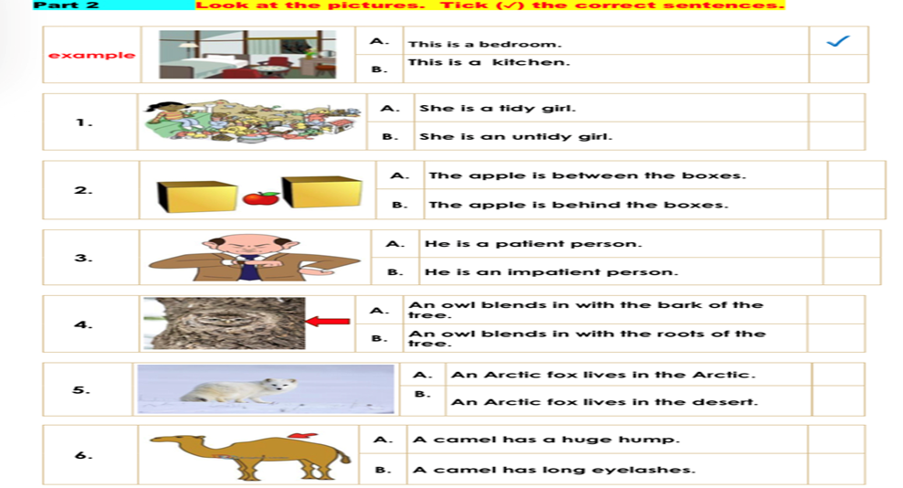
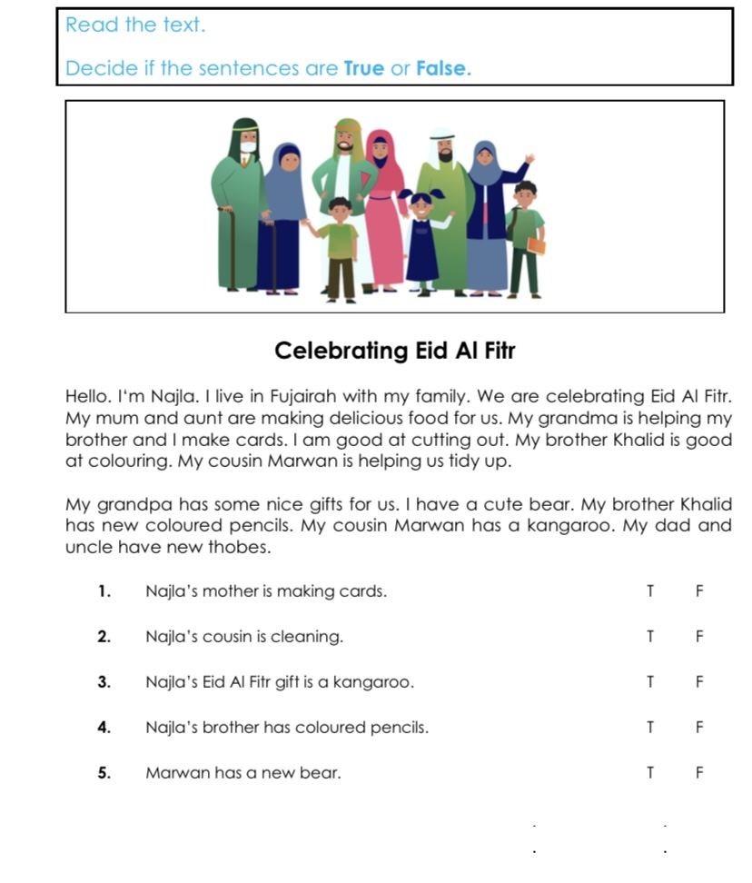

Teacher: Rana Almoukdad

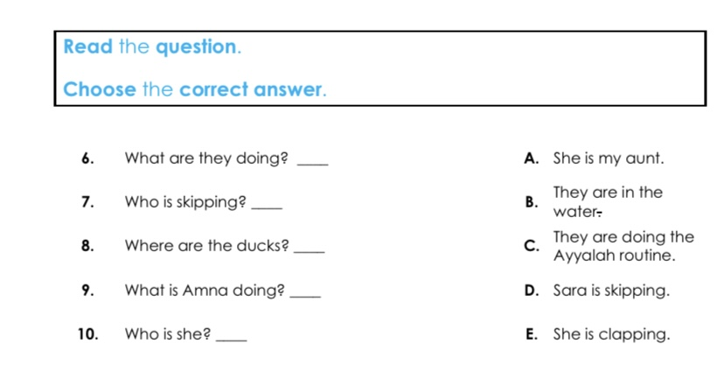

Teacher: Rana Almoukdad
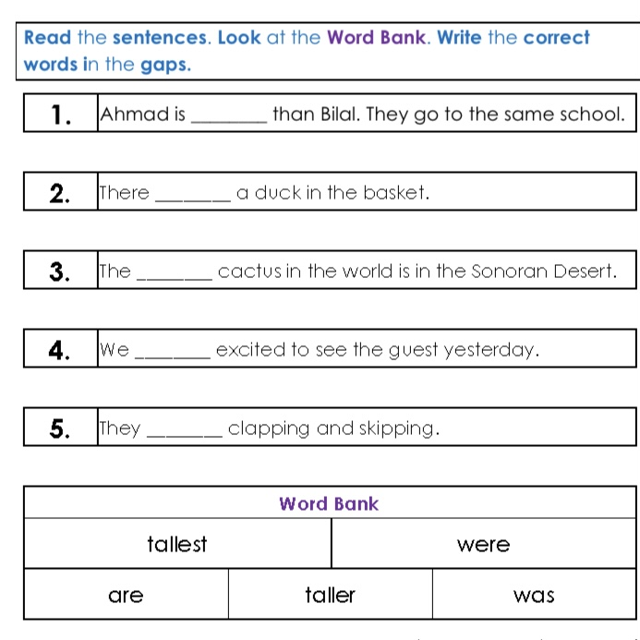
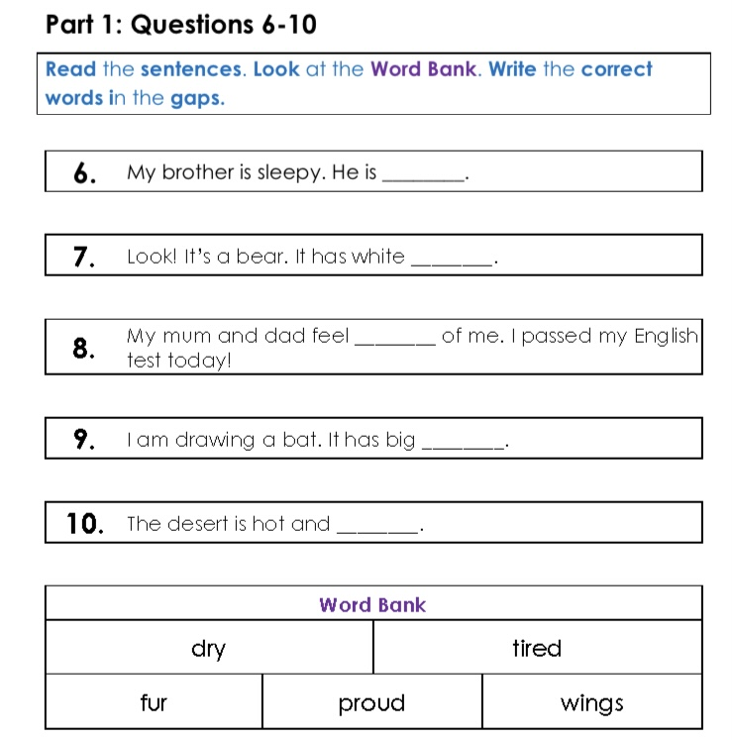
Teacher : Rana Almoukdad

