Reading and writing assessment- First semester/2021-2022
English Second summative test
Student name: |  | Grade Three: |  | Date:
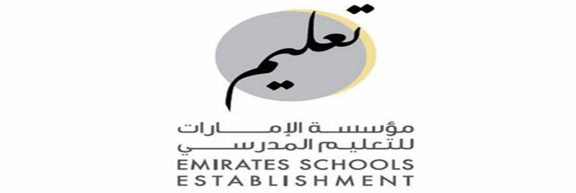

Total:------/10

Read the passage and answer the questions:
marks------/5

Read the text and answer the questions:
Hello ! My name is Sami. Today , I am watching the sky race in Dubai. My dad is one of the runners.
The runners race inside a tall building in Dubai.
They run up the stairs. The building has 52 floors. That is a lot of stairs! The winner is the person with the fastest time. Do you think my dad is the first ?
Read and choose a, b or c:
1- Sami is watching the ………………
a- the sky race b- the camel race c- the horse race
2-The sky race is in ……………………
A- Abu Dhabi b- Sharjah c- Dubai
3- The building has ………………..floors .
a- 50 b- 51 c- 52
4-The runners run up the ………………
a- road b- stairs c- floor
5- The winner person with the ……………………is the time.
a- slowest b- fastest c- shortest

Choose the correct answer:
marks------/5

1.There -------one book.
a- are b- is c- am
2. Jill, is this backpack yours?
Yes, it’s ………………………
a- mine b- yours c- his
3. He……………a hair brush in his backpack.
a-have got b- has got c- have
4. Where is the ball?
a.It is under the ball b.She is in the room c. He is on the wall
5. What is your job ?
a- I am a teacher b. My name is Ali. c.I’m 7 years old.
6. Where do you work?
a. she works at school . b. I work at hospital. c. he works at police satation
7. What do you teach ?
a- She teaches Arabic. b.You teach Math c. I teach English
8. How many books are there ?
a- There are ten books b.There are two pencils c. There is one book.
9.1st means :……………..
a. the first b. the second c. the third
10.4th means the………………..
a- the third b. the fifth c. the fourth

Write 2 sentences about yourself using always- usually- sometimes- never
,start with capital letter, leave space and use punctuation:
1-……………………………………………………………………………………………………

2-………………………………………………………………………………………………………

Rubric | Sentence structure | Punctuation and space | spelling
marks | 1 | 0.5 | 1
The end

