Jobs
Read the example then write sentences about jobs:

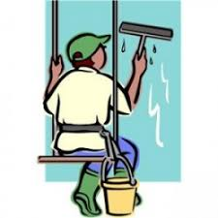 | I clean windows.  I am a window cleaner.
I bake bread.
………………………………

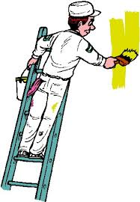 | ………………………………  ………………………………
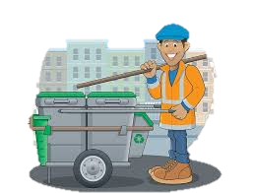 | ………………………………  ………………………………
Mastered

Mastered with help

Not mastered
Jobs
Read the example then complete sentences about jobs:

I clean windows.

I am a window cleaner.
I bake bread.
I am a ………………

I paint.

I am ………………

I clean the street.

………………………………

Mastered

Mastered with help

Not mastered

