Words List:
Word | Meaning | Picture
detective | someone whose job is to discover information about crimes.
measure | to discover the exact size or amount of something. | 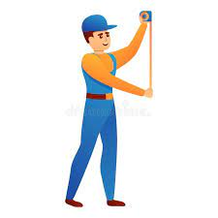
include | to contain something as a part of something else.
cost | the amount of money needed to buy.
guest | a person who is visiting you, | 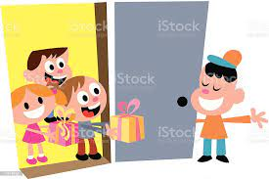
napkin | a small piece of cloth or paper. | 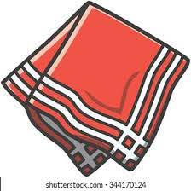
Pigeon | a kind of birds. | 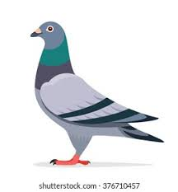
servant | a person who is working in another person's house.
Hawk | a type of large bird that catches small  birds and animals for food. | 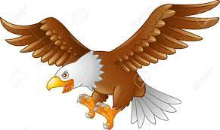
Post office | a place where stamps are sold.
whisper | to speak quietly. | 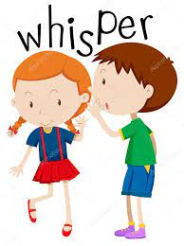
popular | Very common | 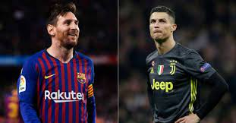
storm | very strong wind.
folktale | a traditional story. | 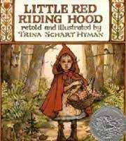

- Revise the words and meanings.
- Choose any 3 words and use them in full sentences:
Example:
Pigeon:
Pigeons can fly.
- --------------------------------------------------------------------------------------------------------------------------
- --------------------------------------------------------------------------------------------------------------------------
- ------------------------------------------------------------------------------------------------------------------------

Grammar:
Maze Task
In ancient times, a rich man lived in Cairo. One day, he (1) ………. (say- Sayed- said), ‘I want to eat some of my favourite cherries.’ The rich man didn’t want cherries from Cairo. He wanted cherries from Antioch. So the rich man (2) ………… (write- wrote- writing) a message on a small piece of paper. He (3) ……… (gives-gave- given)
the message to his servant, who ran out of the house. ‘Use the fastest pigeon in Cairo!’ shouted the rich man. That afternoon, one pigeon (4) …………. (flew- fly- flyed) to Antioch. A servant (5) ………. (catch-catched- caught) the pigeon in his hands, read the message and made a plan. He (6) …………. (tell-telled- told) a cherry farmer to put 1200 cherries into 1200 tiny bags. Three days later, 600 pigeons arrived at the rich man’s house in Cairo. Each pigeon had two cherries in two bags. The rich man (7) ……… (ate- eaten- eats) the cherries. He was very happy!

