Coffee, Coffee and More Coffee
- Coffee is one of the most popular beverages in the world. It is second only to tea in popularity. Coffee has been drunk since the 15th century and has continued to gain popularity ever since.
- Coffee is made from the seeds of the coffee plant. The seeds are taken from the fruit of the coffee plant, cleaned and dried. The beans are green, but most types of coffee use beans that have been roasted, or cooked in ovens, until they are very dark brown. The roasting completely changes the taste of the coffee. Coffee beans must be ground, or crushed, into a powder, before making any type of coffee. Then the powder is mixed with hot water for a long enough time to get the flavor from the beans. There are three basic methods for making coffee: boiling, steeping or pressuring the grounds.
- The oldest method is boiling. Crushed beans are boiled in water and then the grounds sink to the bottom and the coffee liquid is poured off. Turkish coffee and Arabic style coffees are made in this way. They differ in that Turkish coffee uses strong dark roasted beans and sugar in the water while Arabic coffee uses green unroasted beans and produces a light green cup of coffee. Neither is usually served with milk. Another variety of boiling is called percolating. Here the coffee sits above the boiling water, and boiling water travels over the ground coffee beans and falls back into the boiling water. In percolating, the strength of the coffee depends on how long the boiling water goes over the beans. It is then served with or without milk and sugar.
- In steeping, coffee grounds and boiling water are combined in a container and a filter is on top. When the coffee is strong enough, the filter presses the coffee grounds to the bottom and the beverage is poured. French press coffee is made in this way. If wanted, milk and sugar are then added.
- Pressured coffees, or espresso type coffees, are perhaps the most popular nowadays. A high pressure machine forces boiling water through the coffee grounds. Espresso is the most basic form and is served strong in small amounts. If this is too strong, water is added and it is then called Café Americano. For an even weaker coffee, an espresso is added to a larger amount of boiled water. This is known as a “long black.”
(403 words)
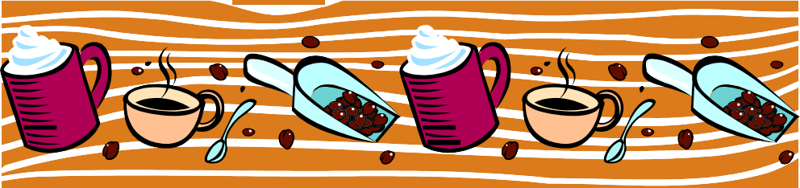

  - The word beverages in Paragraph 1 is closest in meaning to
    - popularity b. drinks c. food d. coffee

  - The coffee plant has bright colored flowers.
    - True b. False c. Not Given

  - What types of coffee use crushed coffee beans?
    - all types c. only Turkish and percolated
    - only percolated and steeped d. only roasted types

  - How many types of boiled coffee are mentioned in Paragraph 3?
    - one b. two c. three d. four

  - Which boiled coffee is often drunk with milk and sugar?
    - all boiled coffee c. Arabic
    - Turkish d. percolated

  - What is the purpose of Paragraph 4?
    - To explain how boiled coffee is made
    - To explain how steeped coffee is made
    - To discuss the parts of the coffee plant
    - To discuss pressured coffee

  - How many examples of steeped coffee are given in Paragraph 4?
    - one b. two c. three d. four

  - In Paragraph 5, what does this” refer to?
    - coffee grounds c. espresso
    - Café Americano d. long black

  - If you like very weak coffee, which pressured coffee is best for you?
    - pressured coffee grounds c. espresso
    - Café Americano d. long black

